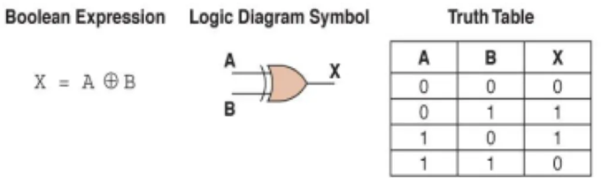Programming project: Logic gate simulator

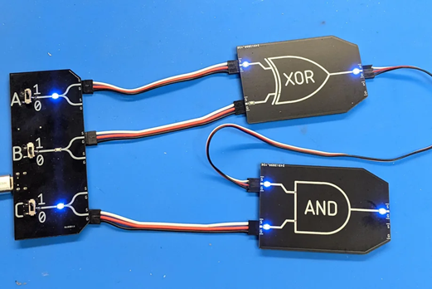

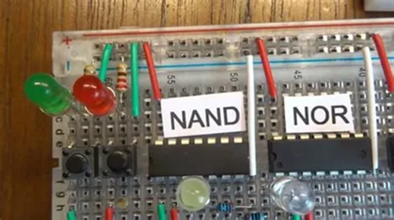Contents

Analysis 2

Problem 2

Computational approach 3

Stakeholders 3

Research: 4

Logic.ly 4

Phet Circuit construction kit 5

Interview with computer science teacher 5

Interview with student who studied logic gates: 6

Analysis 6

Specify the proposed solution 6

Essential features of computational approach 7

Limitations of proposed solution 7

Success criteria 7

Design 8

Decomposition 8

Describe the solution 8

Describe parts of solution with algorithms 12

Usability features 13

Approach to testing 14

Developing the coded solution 15

Breakdown of first iteration 15

Analysis of first Iteration 19

The first prototype: 19

Client feedback on first iteration 20

Breakdown of second iteration 20

Analysis of second iteration 27

The second prototype 27

Client feedback of second iteration 29

Breakdown of third iteration 31

Analysis of third iteration 37

The third prototype: 37

Client feedback on third iteration 39

Breakdown of fourth iteration 40

Analysis of fourth iteration 43

Fourth prototype 43

Feedback on fourth iteration 44

Evaluation 44

Testing for robustness 44

Usability testing 47

Success of the solution 48

Describe final product 50

Maintenance and development 50

Potential further development 51

# Analysis

## Problem

Logic gates are a critical part of electronics and computer science and understanding how to use them is important to understanding computers and designing electronic devices. However, it is very difficult to demonstrate them in real life as they are expensive, small and it is hard to show what is happening. This may prevent people from learning about this area. My program will attempt to make logic gates more accessible.

These skills will enable people get jobs designing computer hardware, digital circuits, embedded systems, FPGAs and more. As well as improving problem solving skills.

## Computational approach

The problem lends itself to a computational approach as computers and programming are built upon these exact same logic gates, it is essentially a computer simulating itself and all programming languages have the basic logic gates built in. Therefore a computer is ideal for computing logic gates, and can also be used to make a interactive GUI to edit circuits. The computational approach can give immediate confirmation of a logic circuits function and output and allow the user to construct functional logic circuits. The only other way to do that would be to buy purpose built hardware. But this has other issues including the cost of purchase and maintenance and the logistics of finding and setting up such equipment. But my solution does not have these issues as it is expected that computers are already available for all students.

## Stakeholders

The main stakeholders are teachers and their students as they will be the people using my program.

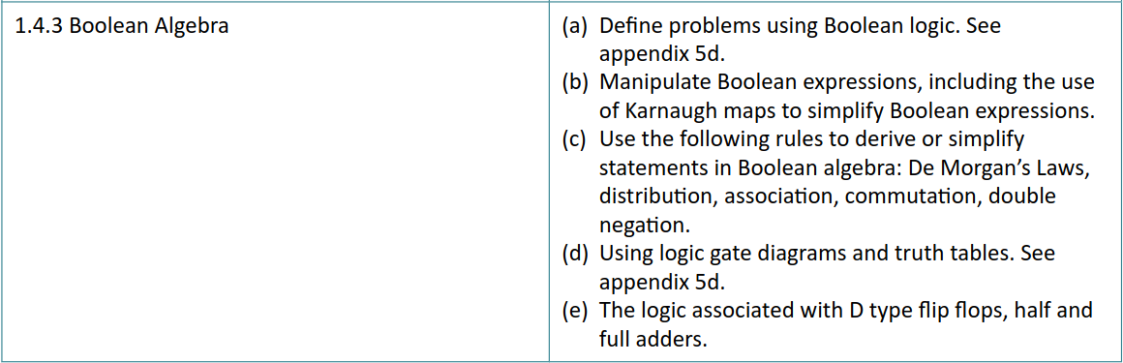Logic gates are part of the GCSE and A level computer science curriculum. This image is from the OCR A level specification. Students are required to gain an understanding of the basics of logic including some more advanced circuits in part (e). And this topic is also part of the GCSE curriculum.

This topic is very hard to teach as it is abstract and unintuitive and usually taught using pen and paper that has no instant feedback and is unappealing to students. My program will aim to allow students to “mess around” with logic gates and therefore gain an understanding of the topic. To achieve this my program needs to be fun to use with appealing visuals and intuitive controls. Students using this program will have to learn the difficult topic of logic gates so my program must be as easy to understand as possible to avoid adding making the learning process even harder. A level students will need to be able to use my program to construct more advanced circuits like those mentioned in the specification.

As my program will be run on school computers it must be run locally and not require internet access so it can be used even if school Wi-Fi is not working. My program will be free to use so it is easily assessable to schools and students.

## Research:

### Logic.ly

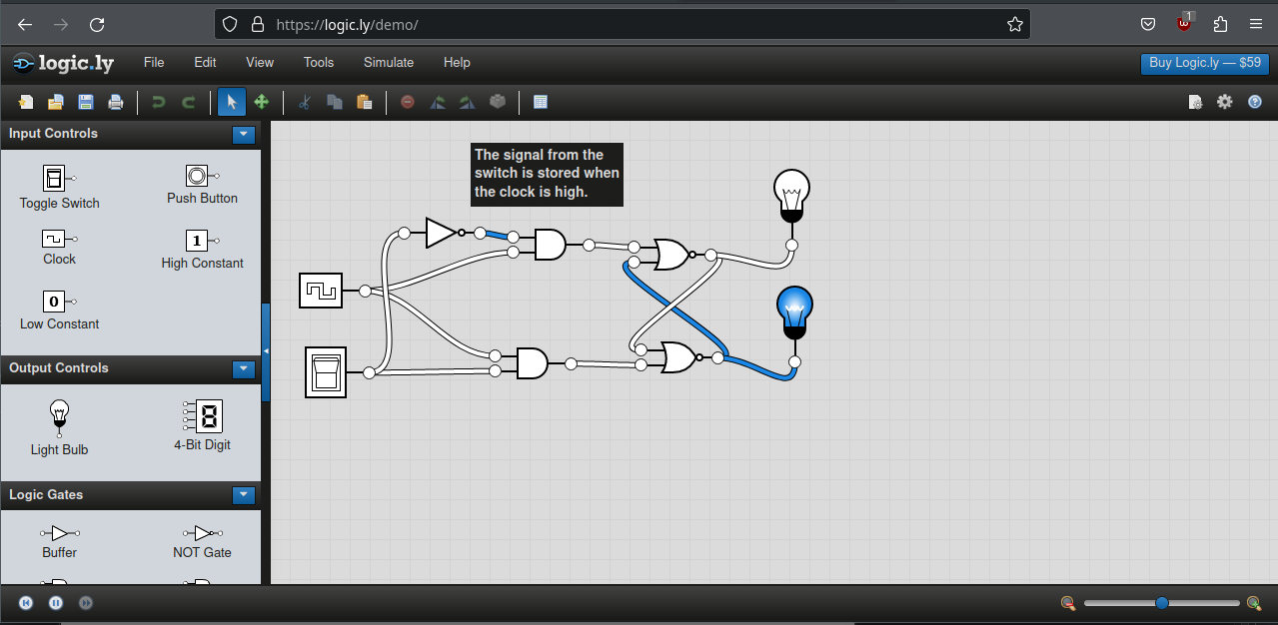https://logic.ly/demo/

Logic.ly is a popular logic gate simulator. It has all the basic functions of a common logic gate simulator and some advanced features.

Logic gates are constructed on a 2D plane and this is fairly realistic to the way integrated circuits are constructed in real life, etched into a silicon wafer. And it makes the program simpler to create and easier to understand than working in 3 dimensions.

It has drag and drop components and new components can be created by clicking on a button at the left. Connections are created by clicking on what I call 'connection points'. If you click on a connection point a wire will appear connecting the 'connection point' to the mouse position that can be dragged to another component. It has the ability to modify the components that have already been placed with a menu. It has a clear and professional looking UI but it may be overwhelming for new users.

It has all the major logic gates and flip-flops as well as light bulbs and 4-bit digit outputs. I will implement all these components into my program.

The limitations are that it is made for advanced users and is uninviting for newcomers. It also costs $559 for a class of 20 and if students wish to practice at home they will have to pay $59 for the privilege. Therefore, it is not a cheap, easily accessible option for many schools or students. It does however have a free online preview version but it lacks functionality.

It supports Windows and MacOS but not Linux. I want my program to support all operating systems especially those that don’t cost a large amount of money and aren't controlled by monopolistic corporations.

### PHET Circuit construction kit

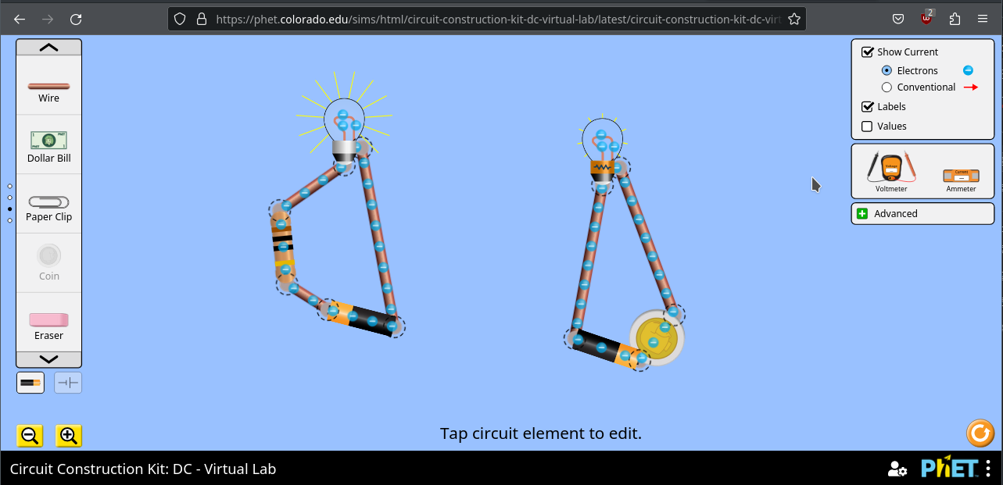https://phet.colorado.edu/sims/html/circuit-construction-kit-dc-virtual-lab/latest/circuit-construction-kit-dc-virtual-lab_en.html

This is a electrical circuit simulator (not a logic simulator). It is web based so can be used without downloading it. The visuals are basic but this makes it easy to understand and looks approachable and not overwhelming. It uses drag and drop components with the same “connection points” idea but the controls are finicky and overcomplicated.

It is made for education and has some fun features to encourage experimentation. For instance you can connect a coin and a rubber to a circuit with the idea that students will learn through experimentation that one is an electrical conductor and the other an insulator. I wish to mimic this kind of learning though experimentation in my program.

It has a few limitations like the unintuitive controls and the inability to save your work. It is also not a logic simulator.

### Interview with computer science teacher

To determine how logic circuits are taught to students and if there is a need to improve this area of teaching I interviewed Mrs H. The answers are summarised.

Are logic gates part of the GCSE and A level curriculum?

Yes

What age are the students who are taught this?

Year 7 and 8 and GCSE level if the subject is chosen.

How is this topic usually taught to students?

Theory, worksheets and PowerPoints.

What are the problems with this approach?

Not engaging, would be better if there were online or game based resources.

What is the most complex logic gate students have to learn at GCSE level?

7 main logic gates.

What features should a logic simulator have to teach effectively?

Go beyond basic functionality and show the real-world applications.

Are computers available for all students one each or in groups?

Yes there are enough computers for every student.

### Interview with student who studied logic gates:

I did this to gain an understanding of the problem from the students’ perspective. I interviewed A, a student who previously studied logic in school.

What year where you taught logic circuits?

Year 7 and 8, I think

Where the lessons engaging?

No, infotech lessons where quite boring, most people just took the opportunity to talk to their friends. I’m pretty sure we often had a supply teacher.

Did the lack of engagement affect your learning?

I guess

Where the lessons successful in teaching you the topic and do you still remember what the logic gates do?

I remember the “or”, “and” and “not” gate but not any of the others.

Would an opportunity to use these logic gates in a simulator improve your engagement and/or understanding?

Yes I actually learned this stuff from Minecraft redstone by using these gates for an actual purpose in my base. (Note: redstone is a logic based electricity system that can be used to construct fun and useful machines in Minecraft)

### Analysis

The school currently uses PowerPoints and worksheets to teach this topic. Using a more interactive method like a logic gate simulator could improve students engagement and understanding. Students learn when they are having fun (for instance in Minecraft) and by creating a logic simulator this fun can be channelled into a proper educational tool to teach logic.

## Specify the proposed solution

This project will be made in Python with the Pygame module so I will require these installed in order to program the project. Python provides the basic programming constructs to make a program and Pygame provides the graphical output, a way to gather user inputs and other game making features like the sprite object with functions to set an image and check for collisions. I will use the text editor CodeOSS to write the code as it helps to write and debug code and I am familiar with it.

To create the images of logic gates I will use the image editor GIMP as it has digital drawing and cropping capabilities.

The end user will not have to have Python or Pygame installed on their computers as the code will be compiled into machine code. As Python and Pygame supports PCs using Linux, MacOS, Windows and a long list of other operating systems my code will be able to run on all these.

The hardware components are those of almost all PCs: a keyboard and mouse to input and interact with the program and a monitor to see the output of the program.

## Essential features of computational approach

My program will use a GUI to allow the user to design circuits using the mouse. They will drag and drop logic gates onto the screen and connect them with wires. The screen will be rendered in a main loop that will run at 60 frames per second to make the program feel smooth and responsive.

I will include at least the 7 main logic gates, an input switch and an output lamp. The components will be simulated according to the rules of logic gates and will update whenever appropriate. The program will display its state to the user by the output lamps and by the wires changing colour. Red indicating off and green indicating on.

Finally the program should allow the user to save their work to a file in persistent storage so they can load it later to continue working on their circuit.

## Limitations of proposed solution

As logic gates are a clearly defined computational system the simulation will be accurate. However, as my program is focused on GCSE and A level students it will not have editing features suitable for advanced users. The circuit editor will not contain features like custom circuits that make very large circuits easier to build and understand. Python is not a very fast language and my program will not be using multiple cores or the GPU so there may be performance issues with very large circuits.

## Success criteria

In order for my project to be a success it must allow the user to construct logic circuits using its GUI and then simulate these circuits correctly according to the rules of the logic circuits and update the GUI to show the user the state of the wires.

This means that the program must use Pygame to open an output window and display the GUI. It must also use Pygame’s key press handling capabilities to collect user input and respond to it.

The program should be colourful and visually appealing and all GUI features easy to understand. It must not require an internet connection so it can be used offline. These features make the program useful to my main stakeholders.

Editing capabilities:

1. The program should provide an easy one click capability to create an unlimited number of logic gates with options to create at least the 7 major gates as well as an input and output component.
2. It also needs to allow the user to create wires that visually connect the different logic gates and they will also need to be connected internally to allow correct simulation.
3. The program must protect the user from connecting components in a way that cannot be simulated as it makes no sense, to do this it must follow the rules I have created:

* No connecting component’s inputs to another component’s inputs, or outputs to outputs
* Only one wire can connect to one input of a component, however multiple wires can connect from an output

1. Logic gates can also be created with a keyboard shortcut to make creating circuits faster for experienced users
2. Finally, the program must allow the user to delete components that are not wanted.

Justification: these features are required to allow a seamless editing capability that does not restrict the user’s ability to construct logic circuits.

The logic circuits must also be accurately simulated and behave identically to a real logic circuit. To demonstrate this the program must be able to construct and simulate a 4 bit binary adder (using the normal carry adder design) correctly, a clock made from not gates and wires and all main flip-flops especially the D type flip-flop.

Justification: the user needs to see the logic gates functioning to understand what they are doing in order to learn. The A level specification requires that the circuits mentioned are understood so my program must demonstrate them correctly.

Finally it must also be able to save the state of the logic circuits to a file that is stored in persistent storage and then load from that file so the users work can be saved even when they close the program. After saving and loading the circuit must be identical to what the user created before saving.

Justification: designing complex logic circuits is time consuming and the user may want to take a break so they will need it to be stored persistently.

# Design

## Decomposition

My project can be broken into three distinct parts, the GUI circuit editor and the logic simulator and the save/load capability. The GUI circuit editor allows the user to design the circuit visually and gives a representation with images of logic gates with lines (wires) connecting them together. The logic simulator will update the state of components following the rules of the logic gates. And save/load will take the programs state with all the components and turn it into a file that can be stored in secondary storage in a binary file

## Describe the solution

1. GUI circuit editor

|  |  |  |
| --- | --- | --- |
| Variable | Data type | Use |
| screen | surface (Pygame object) | The thing that is displayed on the monitor |
| running | bool | Controls when the main loop ends |
| length (attribute) | int | Store length of component |
| width (attribute) | int | Store width of component |
| rotation (attribute) | int | Stores bearing that object is rotated |
| rect (attribute) | Custom Pygame type | Stores many details about the sprite |
| background_colour | tuple | Contains rgb value for background colour |
| mouse_pos | tuple | Stores x and y coordinate of mouse position |
| components | Group (pygame data type) | Contains all components so they can be all blitted to the screen |

This part is to allow users to design their circuits using the mouse and keyboard. To pick up a component the user will click on a create logic gate button, this will instantiate a new object of the correct type of component. It will store this component in a variable ‘hovering_component’ and every frame the program will move the image to the mouse position so the image follows the mouse. When the user releases the mouse button the object will be removed from ‘hovering_component’ and therefore will stop following the mouse and remain in its last position. Wires will connect the components visually and can be placed by clicking on the two logic gates the user wants to connect, it will follow the mouse when only one is connected. I will use method called ‘connectTwoPoints()’ that will take two coordinates as parameters, it will resize, rotate, and correctly position the wire object to visually connect these two points.

def connectTwoPoints(point1, point2)

length = sqrt((point1[0] – point2[0])^2 + (point1[1] – point2[1])^2)

make wires length = length

angle = arctan(abs(point1[0] - point2[0])/ abs(point1[1]- point2[1]))

rotate wire by angle

wires position = point1

end procedure

All components will be stored in a group (a data type built in to Pygame) so they can all be drawn to the screen at once and can easily check for collisions from any of them.

2. Logic simulator

|  |  |  |
| --- | --- | --- |
| Variable | Data type | Use |
| hovering_component (global) | Reference | Stores the component currently being moved |
| current_wire (global) | Reference | Stores the wire currently being moved |
| state (attribute) | bool | Stores if that component is on or off in the simulation |
| inputs (attribute) | list | Stores the components/wires that input into that component |
| outputs (attribute) | list | Stores the components/wires that the component outputs into |
| changes(global) | Reference | Contains object that has been changed by user and will trigger a logic update on that object |

When components are connected to each other they will add a reference to the other objects in their ‘outputs’ and ‘inputs’ attribute so the program knows they are connected. This will form an ordered graph structure.

To update the individual logic gates each logic gate class will have a unique ‘logicUpdate()’ method that looks at the state of its input components and calculates its state following the rules of that logic gate.

psudocode for logicUpdate() method for AndGate:

def logicUpdate()

if inputs[0] and inputs[1]

state = true

else

state = false

endif

for i in outputs

i.logicUpdate()

next

end procedure

My program will use a event driven algorithm where any components that have been changed will be saved and at the end of the loop all changed components will run their logicUpdate() method. This will compute the logic gates ‘state’ based on the state of the inputs and then call logicUpdate() on all its outputs because if one logic gate has changed, its outputs will also need to change. This creates a recursive pre-order depth first search. Using event driven algorithm will allow the simulation to run at a higher frame rate on low spec school laptops and allow very large logic circuits to be possible. As only the components that need to be calculated will be updated and most of the time components won’t do anything.

3. save / load

I will use the Pickle module to serialise the state of the program so it can be saved to a binary file. This means the data will be persistent as it is saved in non-volatile memory.

To save the state of the program I will use a function save on each logic gate object and wire. This will write all the attributes of the object to a list, then the list will be serialised using “pickle.dump” each object will be saved as one line in a binary file “save”. Later on I realise I have to give each component a numerical ID

To load the data from “save” I will read each line and recreate the object from that data as show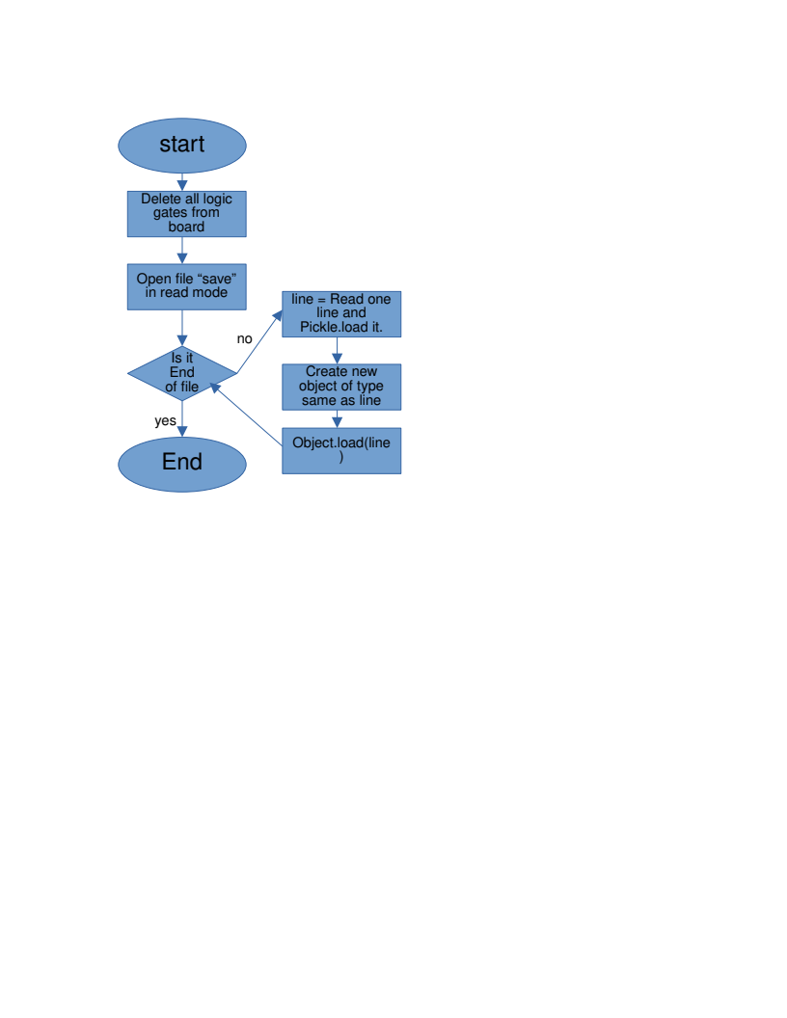n.

The function ‘load’ will take the newly created class and set all its attributes to those from the list “line” so that the new object is identical to the one it is recreating. This will be done for all components.

My program will make use of a main loop to render objects on screen, respond to user input and simulate the logic gates. The main loop end when the user presses the “x” button which ends the main loop by setting “running” to false. Each cycle of the loop will produce one frame. Most of the code will be found in the classes however the main loop will call those methods to make the program function. In the flow chart below I have laid out all the things the the main l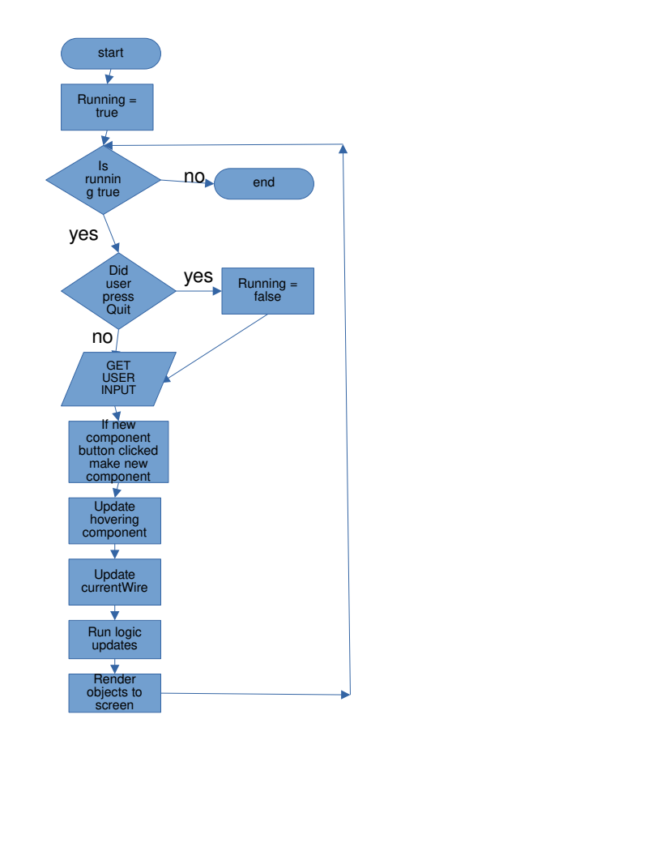oop will do.

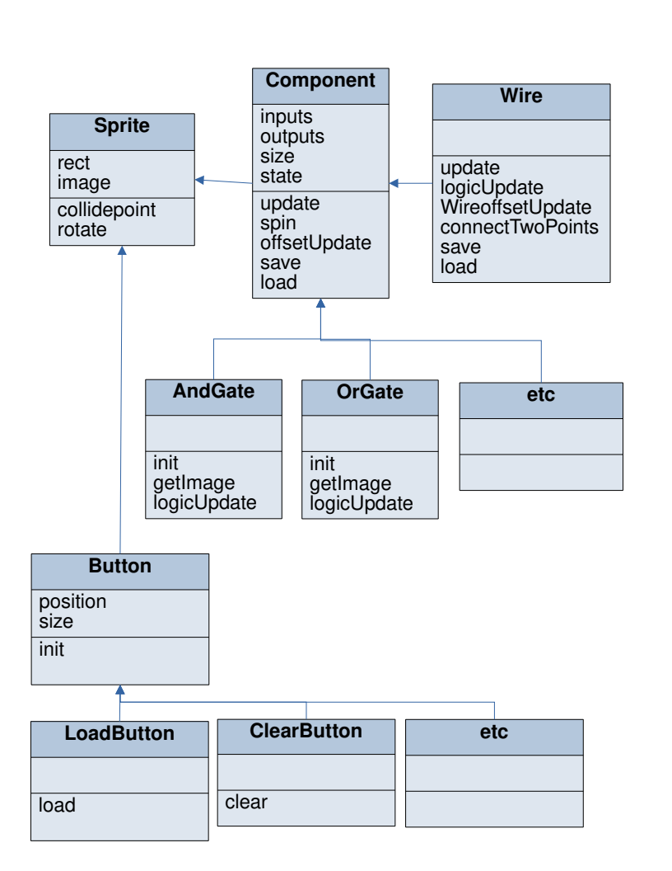

I will use object orientation to create classes for all the logic gates in my program. The built in Pygame class ‘Sprite’ contains many useful methods like ‘collidepoint’ that checks for collisions. My other objects will use these features by inheriting from ‘Sprite’. The abstract class ‘component’ will contain all the attributes to define the basic features of a logic gate object like ‘location’, ‘position’, ‘size’, ‘inputs’. The ‘update’ method is responsible for moving the components as described earlier . All the logic gate classes will inherit from ‘component’. But I will use polymorphism so that each component can have its own ‘logicUpdate’ method so each component will act differently. And so will have its unique image to represent it provided by ‘getImage’.

## Usability features

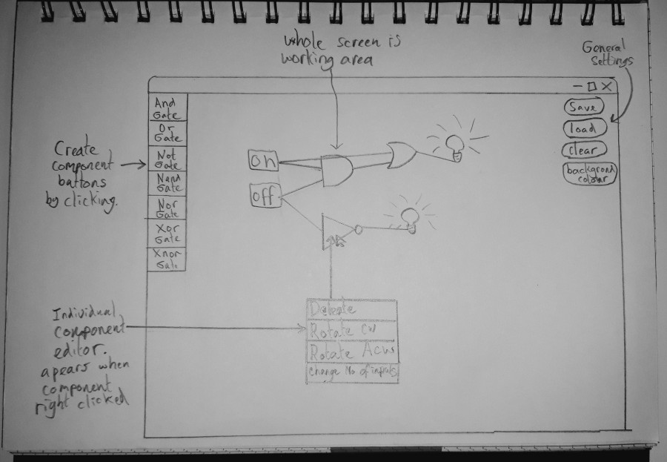Design of layout for GUI inspired by the PHET circuit simulator

My program will be full-screen and the majority of the whole screen space will be an area for building circuits. Along the left side of the screen will be images of logic gates that are buttons to create new logic gate. This should be intuitive as the user will be drawn towards these buttons and click them and this will create components. Components will be moved with a drag and drop system which should be intuitive as it is common in computer programs.

Along the right side of the screen will be labelled buttons for settings, saving, etc. And these will be made to look like buttons similar to other programs so it is clear these are buttons.

For advanced users I will create keyboard shortcuts such as ctrl n to create not gate. This allows them to quickly create and delete components so they can use the GUI editor more quickly.

## Approach to testing

I will use black box alpha testing to check if the program produces the expected output for a given input. My program is suitable for black box testing as the programs behaviour is entirely responding to user input and because my project largely focuses on the graphical output. As there are no security concerns white box testing is not necessary.

As the input method for the program is the mouse and no text inputs there are a lot less unexpected inputs which makes testing easier. All the input is from the mouse or from specific key presses so almost all the test data is normal as there are very few erroneous mouse inputs.

|  |  |  |  |  |
| --- | --- | --- | --- | --- |
| Test No. | Input | Desired Output | Justification | Type of test data |
| 1 | X button at top right | Quit program | Test that the user can stop the program at will. | Normal |
| 2 | Left mouse button when cursor over logic gate button | Create a new component object of the correct type that follows the mouse position | Test that user can create new objects | Normal |
| 3 | Ctrl N | Create NotGate at the mouse position | Test that user can use keyboard shortcuts to create components | Normal |
| 3.1 | Ctrl + any key that isn't a shortcut | Nothing happens | Its not meant to do anything | Erroneous |
| 4 | Left click on a component move mouse and the release mouse button | Only the component clicked on follows the mouse cursor then stops when released. Any wires connected to it remain connected to the correct place | Test that the user can move any component at will | Normal |
| 5 | Click on the component “connection point” | A new wire is created that will connect the point clicked to the mouse cursor | Test that user can create wires that connect the points correctly. | Normal |
| 6 | Continue from test 5. Move near connection point a release mouse. | The wire remains and is visually connecting both connection points | Test that wires can be created to join two components | Normal |
| 7 | Continue from test 5. Release mouse button away from any other component. | The wire disappears | Test that the program will remove unwanted wires | Normal |
| 8 | Attempt to connect a wire from an input to another input. | The wire disappears after releasing the mouse button | The logic rules don’t account for components connected in this way so the program won’t allow it to stop the user confusing themselves | Erroneous |
| 9 | Connect two switches to an AndGate’s inputs and a bulb to the output. Then flick the switches | The bulb switches to yellow ON image only when both switches are ON. Following the rules of an AndGate. | Test that the logic is simulated like the real logic gates | Normal |
| 10 | Create a not gate and connect its input to its output with a wire | The wire flashes on and off 60 times per second | Test that the logic is simulated like real logic gates. And that the update order is correct in an extreme case. | Normal |
| 11 | Create race condition: switch connecting to Notgate and AndGate and output of Notgate also connecting to the Andgate | The Andgate turns off and then on again very quickly | Test that a race condition is handled correctly, this also tests that the update order of logic gates is correct | Normal |
| 12 | Create some components and wires connecting them. Then press “save” button. Then exit the program and reopen it. | The component that where saved are placed back exactly how they where before. Including position, rotation and state. | Test that the user can close the program and then restore their work later. | Normal |
| 13 | Press “clear” button | All components are removed | Check that the user can clear their work when wanted | Normal |
| 14 | Hover over a wire and press backspace | The wire is removed | This is an essential editing feature | Normal |

# Developing the coded solution

My final solution was created in 4 iterations of the agile methodology.

## Breakdown of first iteration

My first iteration starts by coping the code from my previous Pygame project and removing the extra stuff to have a basic Pygame structure.

import pygame

from pygame.locals import (K_LEFT, K_RIGHT, K_UP, K_DOWN)

import math

import itertools

import pickle

pygame.init()

It starts by importing the modules that I will use to make the project. The first module is Pygame which I will use to create the output and take inputs. I also import the constants I will need so I can use the arrow keys as input, I may also need more keys later on. I also initialise Pygame with ‘pygame.init()’. The ‘math’ module is needed to use trigonometry and other maths functions. ‘itertools’ allows me to use more advanced iteration, like iterating though two lists. Finally, the pickle module will be used to serialise data so it can be saved in secondary storage.

file = open("settings.txt", "r")

background_num = int(file.readline())

backgrounds = ((0,51,51), (192,192,192), (100,100,0), (255,255,255), (255,52,52), (255,128,0), (128,255,0), (0,128,255), (127,0,255))

background_colour = backgrounds[background_num]

screen_height = int(file.readline())

file.close

screen_width = screen_height * (16/9)

screen = pygame.display.set_mode([screen_width, screen_height])

pygame.display.set_caption("Logic Gate Simulator")

running = True

clock = pygame.time.Clock()

# -------- Main Program Loop -----------

while running:

#user inputs

events = pygame.event.get()

for event in events:

if event.type == pygame.QUIT:#make close button work

running = False

#draw to screen

screen.fill(background_colour)

pygame.display.flip()

clock.tick(60)

#close program

pygame.quit()

This code creates the basic Pygame structure that creates a window called ‘screen’. A while loop will run for each frame and fills the window it with the background colour at the end of the loop the screen is flipped so it is displayed to the user. ‘clock.tick(60)’ limits the while loop to 60fps by sleeping for the appropriate amount of time. The if statement checks for user input and will break the loop if the user presses the X button at the top of the screen closing the program otherwise it would be impossible to exit the program apart from killing it.

The background colour and screen height are stored in a ‘.txt’ file called ‘settings.txt’ so these features and more in the future can be controlled from this file. In future I will add a way to edit these values from the program.

This forms a working program but lacks any features.

**Adding the logic gates**

Next I make a ‘component’ class to add various logic gates that will be referred to as components.

In order to keep a list of all components I create a group (a pygame data type) called ‘components’ to store all the components. As components will need to be accessed from many classes and from the main loop it will be a global variable.

components = pygame.sprite.Group()

The benefit of using groups is that every member of the group can be easily ‘blitted’ (block transfer) onto the ‘screen’ every frame using components.draw(screen) at the end of the main loop.

class Component(pygame.sprite.Sprite):

def __init__(self):

global components

pygame.sprite.Sprite.__init__(self)

self.inputs = []

self.outputs = []

self.length = self.size[1]

self.width = self.size[0]

self.rotation = 0

self.image = pygame.Surface(self.size)#store original of image for correct rotation purposes

self.image.set_colorkey(remove_colour)

component_image = self.get_image()

component_image = pygame.transform.scale(component_image, (self.width, self.length))

self.image.blit(component_image, (0, 0))

self.rect = self.image.get_rect()

components.add(self)

class AndGate(Component):

def __init__(self):

self.size = [50,50]

self.state = False

super().__init__()

def getImage(self):

return pygame.image.load("images/and gate.png").convert()

Next I create classes to define my components. ‘Component’ defines the basic attributes of a generic component and it inherits from the Pygame class ‘sprite’. This allows it to use many built in Pygame features like ‘rects’ and collision detection. The image for the component is provided by the ‘getImage()’ method of the child class so the correct image is used. Its is scaled and “blitted” onto the components ‘rect’.

Finally this component is made “hovering_component” so that the program will know to make this object follow the mouse. And the component is added to the “components” group.

‘Component’ is an abstract class as it wont be instantiated but provide the template for logic gate classes to inherit. Each individual component (and, or, xnor, etc) inherits from component but changes to be specific to that component using polymorphism.

I create child classes for all 7 main logic gates and an input and output. The constructor for each individual logic gate (like AndGate above) defines its size and starting state (on or off). And then it runs the inherited constructor using super(). The logic gate classes also contain a getImage() method which returns the image to represent the logic gate. Images for each logic gate are a ‘.png’ file stored in a folder called ‘images’ which is loaded into Pygame using pygame.image.load(). The ‘images’ folder is stored in the program folder so that it can be accessed by the code.

To get mouse input I had to modify the user input gathering part in the main loop. It now stores the coordinates of the mouse in the tuple ‘mouse_pos’ and mouse_up and mouse_down events in a boolean variable.

while running:

#user inputs

mouse_up = False

mouse_down = False

events = pygame.event.get()

for event in events:

if event.type == pygame.QUIT:#make close button work

running = False

if event.type == pygame.MOUSEMOTION:#store mouse inputs

mouse_pos[:] = list(event.pos)

if event.type == pygame.MOUSEBUTTONUP:

mouse_up = True

if event.type == pygame.MOUSEBUTTONDOWN:

mouse_down = True

Update method of component. It makes it possible to move components with the mouse.

def update(self, left_mouse_held):

global hovering_component

global hovering_mouse_offset

if hovering_component == None:

if self.rect.collidepoint(mouse_pos) and mouse_down:#pick up object

hovering_component = self

hovering_mouse_offset = (mouse_pos[0] - self.rect.left, mouse_pos[1] - self.rect.top)

elif hovering_component == self:

self.rect.x = mouse_pos[0] - hovering_mouse_offset[0]#move object to mouse position

self.rect.y = mouse_pos[1] - hovering_mouse_offset[1]

if left_mouse_held == False

hovering_component = None

The update method is part of component and is called on each component in the main loop. The variable hovering_component is used to determine which component should be moved to the mouse position. If the user clicks on a component it will become hovering_component and its position will continuously set to the mouse’s position and if they release the mouse then hovering_component will be set to ‘None’ and no components will be moved.

One problem I encountered was that if you click on the component in the middle the component would move so that its top left was at the mouse position rather than where you clicked it. The solution was to store the offset within the component in “hovering_mouse_offset” which is a tuple of two coordinates and this is made when the object is first clicked on. Now the component is instead moved to the mouse coordinates subtract the offset coordinates. So it now follows the mouse from the correct point.

**Buttons to create new logic gates**

Up to now I have been instantiating components from in the code for testing purposes but there needs to be a way to make new components within the program.

class GrabComponentButton(pygame.sprite.Sprite):

def __init__(self,x,y,gate):

pygame.sprite.Sprite.__init__(self)

self.image = pygame.Surface([70,50])

self.image.set_colorkey(remove_colour)

component_image = pygame.image.load(gate).convert()

component_image = pygame.transform.scale(component_image, [70,50])

self.image.blit(component_image, (0, 0))

self.rect = self.image.get_rect()

self.rect.x = x

self.rect.y = y

self.gate = gate

def IsClicked(self):

global components

if self.rect.collidepoint(mouse_pos) and hovering_component == None:

if self.gate == "images/lightbulb_on.png":#instantiate the correct gate

Bulb()

elif self.gate == "images/and gate.png":

AndGate()

elif self.gate == "images/on.png":

On()

elif self.gate == "images/off.png":

Off()

elif self.gate == "images/or gate.png":

OrGate()

So I create simple button class. Each instance of the class will be used make one logic gate. It takes a set of coordinates as parameters that is where it will set its position to and the image of class it is creating. The IsClicked() method will check if it is clicked on and if so call the constructor method for the correct logic gate.

The buttons are instantiated like so:

comp_buttons.add(GrabComponentButton(0, 50, "images/or gate.png"))

comp_buttons.add(GrabComponentButton(0, 100, "images/not gate.png"))

comp_buttons.add(GrabComponentButton(0, 150, "images/and gate.png"))

comp_buttons.add(GrabComponentButton(0, 200, "images/on.png"))

comp_buttons.add(GrabComponentButton(0, 250, "images/off.png"))

comp_buttons.add(GrabComponentButton(0, 300, "images/switch_off.png"))

comp_buttons.add(GrabComponentButton(0, 350, "images/nor_gate.png"))

comp_buttons.add(GrabComponentButton(0, 400, "images/nand_gate.png"))

comp_buttons.add(GrabComponentButton(0, 450, "images/xor_gate.png"))

comp_buttons.add(GrabComponentButton(0, 500, "images/xnor_gate.png"))

## Analysis of first Iteration

### The first prototype:

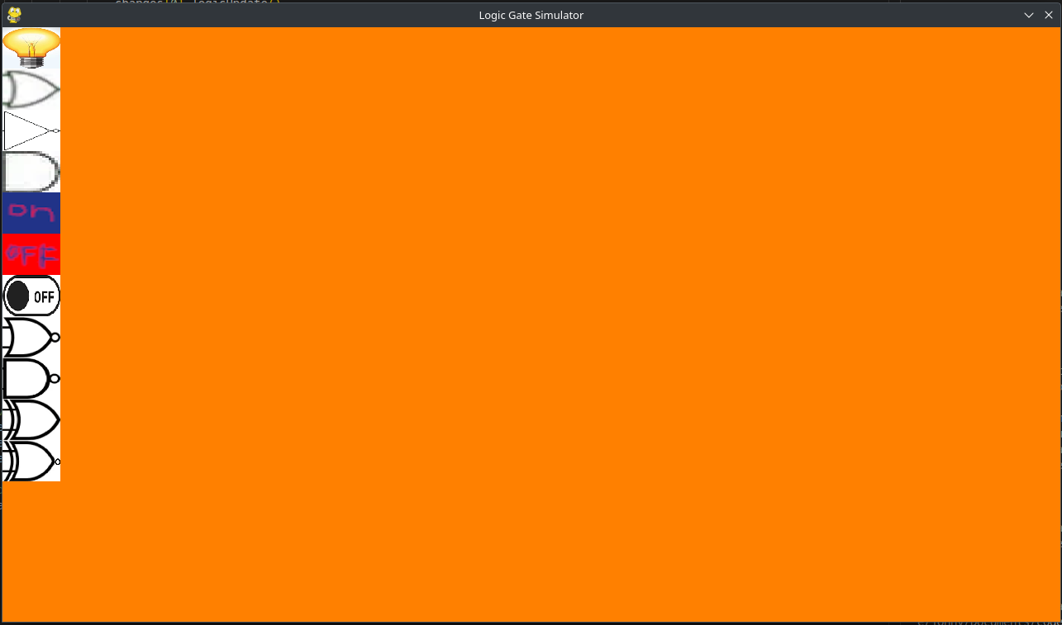The first prototype set up the basics of a Pygame program. It opens a window and refreshes the screen every cycle of the main loop. Along the left of the screen is component buttons, 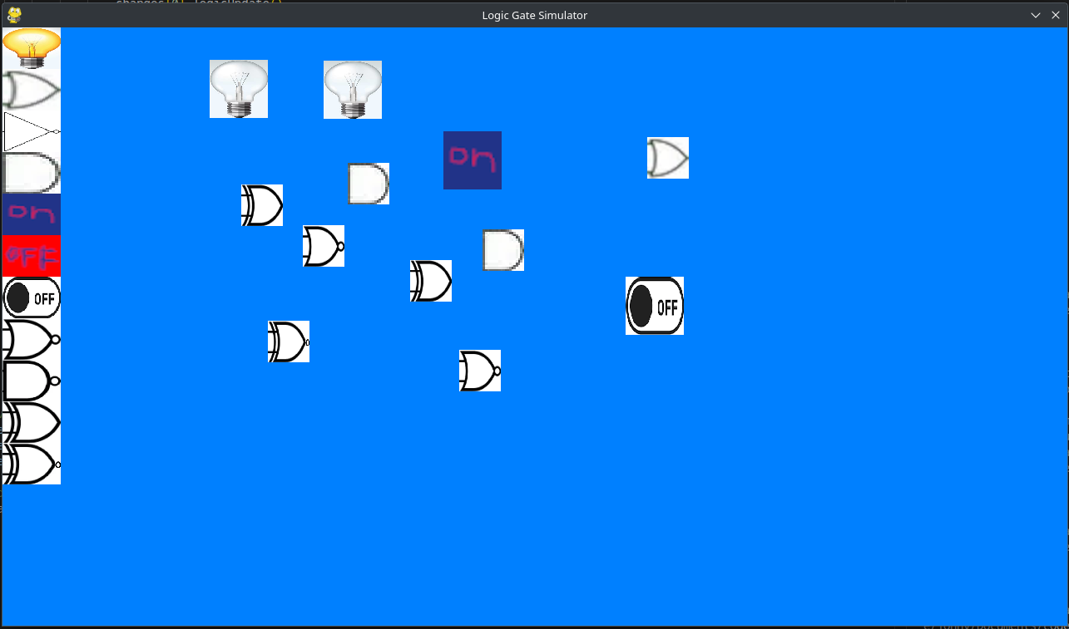these create a new logic gate when clicked.

An unlimited number of components can be created and moved using the mouse. All 7 major logic gates can be created as well as a high and low constant, a switch and a lightbulb output. None of these components currently do anything.

The first iteration produced an incomplete prototype which demonstrated the UI and controls but had no functionality.

### Users feedback on first iteration

As the program is incomplete users gave feedback on features present.

They praised the controls and found the drag a drop to be robust and intuitive. They also agreed with the positioning of the “grab_component_buttons”. However they criticised the logic gate graphics, their white borders and that some of them are blurry and low resolution. However artwork is not my priority at the moment.

## Breakdown of second iteration

**Logic gate ‘sticks’**

In order to allow wires to connect components together they need to have an anchor point.

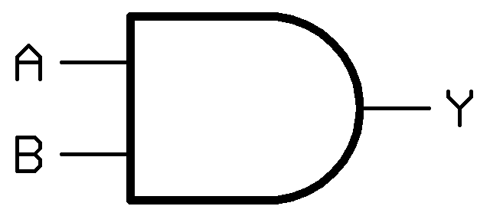

In my design this was going to be defined as a vector offset from the components position and the visualisation was going to be part of its image like the image above. It has 3 ‘connection points’. However I have decided to change my design as I want to be able to change the number of ‘sticks’ on a component.

To do this I make ‘sticks’ its own object with its own image. They also contain attributes storing the component they are connected to and the wires they connect to (once I make wires). Sticks move to the correct position next to a component using the moveToInp() and moveToOut() methods.

class Stick(pygame.sprite.Sprite):

def __init__(self, type, comp):

pygame.sprite.Sprite.__init__(self)

self.type = type#input stick or output stick

self.its_component = comp

self.its_wires = []

self.image = pygame.Surface([30,10])#store original of image for correct rotation purposes

self.image.set_colorkey(remove_colour)

component_image = pygame.image.load("images/sticky bit.png").convert()

self.image.blit(component_image, (0, 0))

self.rect = self.image.get_rect()

sticks.add(self)

def moveToInp(self, x, y):

self.rect.right = x

self.rect.top = y+5

self.connection_point = (self.rect.left + 3, self.rect.centery)

def moveToOut(self, x, y):

self.rect.left = x

self.rect.top = y+5

self.connection_point = (self.rect.right - 3, self.rect.centery)

In order to make sticks move as part of their component object I modify the component update class. This code runs after hovering_component is moved to the mouse position.

elif hovering_component == self:

self.rect.x = mouse_pos[0] - hovering_mouse_offset[0]#move object to mouse position

self.rect.y = mouse_pos[1] - hovering_mouse_offset[1]

stick_seperation = 20#move sticks

stick_start_y = self.rect.centery - ((stick_seperation * self.no_of_inputs) / 2)

for i in range(0, len(self.inputs)):

self.inputs[i].moveToInp(self.rect.left, stick_start_y + (stick_seperation * i))

stick_start_y = self.rect.centery - ((stick_seperation * self.no_of_outputs) / 2)

for i in range(0, len(self.outputs)):

self.outputs[i].moveToOut(self.rect.right, stick_start_y + (stick_seperation * i))

After “hovering_component” is moved the code iterates through all the “sticks” connected to that object and updates their position maintaining the correct separation (of 20 pixels) it does this for both input and output “sticks”

**Adding wires**

At last I am ready to make a “wire” class

class Wire(pygame.sprite.Sprite):

def __init__(self, stick, itoo, onoff):

global current_wire

self.size = [7, 75]

self.length = self.size[1]

self.width = self.size[0]

self.rotation = 0

self.outputs = None

self.inputs = None

self.pos_stick = stick#stores the potential stick to connect to when wire is placed

self.itoo = itoo#(Input TO Output) stores if this wire was created by clicking on an input or an output

self.state = onoff#make wire spawn in on state if it is created from a component that is on

pygame.sprite.Sprite.__init__(self)

self.original_image = pygame.Surface(self.size)

self.original_image.set_colorkey(remove_colour)

if self.state:

self.component_image = pygame.image.load("images/green_wire.png").convert()

else:

self.component_image = pygame.image.load("images/red_wire.png").convert()

self.original_image.blit(self.component_image, (0, 0))

self.image = self.original_image

self.rect = self.image.get_rect()

hovering_component = self

current_wire = self

The constructor is similar to that of component defining all its position and size attributes. It also contains some unique features. As wires are created from a component they initially rotate around their origin until the other side is placed on an object. To do this they are passed data relating to their potential future connections. The attribute “posStick” stores a reference to the stick object it was created from and “itoo” stores if the wire was created from a “input stick” or an “output stick” this is relevant when the wire is connected to another object and its “inputs” and “outputs” are determined.

From a previous Pygame project I know that when an image is rotated in Pygame the rotation is not lossless and after rotating several times it quickly creates a very bad looking result. To fix this the wire object stores two copies of the image: ‘original_image’ and ‘image’. ‘image’ is the one that is displayed to the user but whenever the wire is rotated it creates a new ‘image’ starting from ‘original_image’ as ‘original_image’ is never rotated and never ‘ruined’.

The image “red_wire.png” is again made in GIMP and the image is very long so that even if the wire is made very long it will still have image to display.

def spin(self, amount):

self.image = pygame.transform.rotate(self.original_image, amount)

self.rotation = amount

Next I make a spin method in the wire class. Its job is to rotate wires correctly without distorting like Pygames built in function. It does this by rotating only “original_image” and storing the result in image to be displayed as normal. It also updates “self.rotation” to the new value as it will be needed later.

def connectTwoPoints(self, point1, point2):

#stretch

self.length = math.sqrt(((point1[0] - point2[0]) ** 2 ) + ((point1[1] - point2[1]) ** 2 ))

self.size[1] = self.length

self.original_image = pygame.Surface(self.size)

self.original_image.set_colorkey(removeColour)

if self.state:

self.original_image.blit(green_wire, (0, 0))

else:

self.original_image.blit(red_wire, (0, 0))

self.image = self.original_image

angle = math.degrees(math.atan(abs(point1[0] - point2[0])/ abs(point1[1]- point2[1])))

#bearings from south clockwise positive

if (point1[0] - point2[0]) > 0:#mouse right of ob

if (point1[1] - point2[1]) < 0:#mouse above obj

bearing = 180 - angle

else:#mouse bellow obj

bearing = angle

else:#mouse left of obj

if (point1[1] - point2[1]) < 0:#mouse above obj

bearing = 180 + angle

else:#mouse bellow obj

bearing = 360 - angle

self.spin(bearing)

#move to correct point

self.rect.topleft = self.get_corner_from_connection_point(point2)

self.set_connection_point_coord()

When wires move they need to visually connect two points together this is required in several places in the code so I made it its own method. This function takes two coordinates and stretches, rotates and positions the wire to connect these points.

To determine the length that the wire should be I use Pythagoras’ theorem with the two coordinates given. The wires sprite is then resized to fit and the image is blitted onto the new surface. I actually modify “original_image” as it may be required to rotate it later and resizing is lossless.

green_wire = pygame.image.load("images/green_wire.png").convert()

red_wire = pygame.image.load("images/red_wire.png").convert()

As converting images to the Pygame is a slow process. To improve performance the image is cached in RAM in a variable “red_wire” and “green_wire” at the start of the program so this process is only done once rather than every time a wire is moved.

Next it determines the bearing between the two points. To get the angle I used trig, these functions are provided by the math module. I used arctan as the opposite and adjacent values where easiest to find by a simple subtraction. However, this just gave the angle to the nearest axis not the bearing so I used an if statement that determines what quadrant the angle is in and then added or subtracted the appropriate angle to get the bearing.

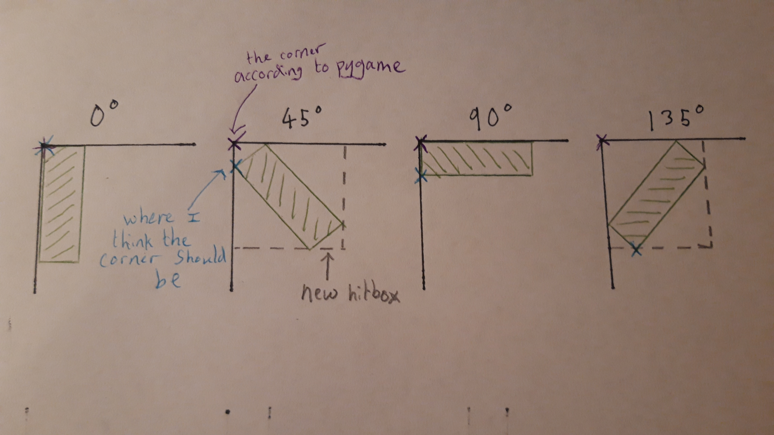Finally, I needed to move the wire to the correct location. But I encountered an issue with the way Pygame rotates objects. Rather than rotate around its centre or its corner Pygame rotates objects in a strange way. I realised that Pygame was not designed for something so precise. However, after some observation I realised that it is not random and I made a diagram to make sense of it. Pygame rotates objects around the black cross.

Using trigonometry, it is possible to find the vector between “Pygame’s corner position” and the actual corner position. So this can be treated as a maths problem.

def getCornerFromConnectionPoint(self, point):

temp2 = (point[0] - ((self.width/2) * math.cos(math.radians(self.rotation)) + (0) * math.sin(math.radians(self.rotation))), point[1] + ((self.width/2) * math.sin(math.radians(self.rotation)) - (0) * math.cos(math.radians(self.rotation))))

if self.rotation == 0:

return temp2

elif self.rotation <= 90:

return (temp2[0], temp2[1] - math.cos(math.radians(90-self.rotation))* self.width)

elif self.rotation <= 180:

temp = temp2[1] - (self.width * math.sin(math.radians(180-self.rotation)))#wrong

return (temp2[0] - math.cos(math.radians(180-self.rotation)) * self.width, temp - (math.cos(math.radians(180-self.rotation)) * self.length))

elif self.rotation <= 270:

return (temp2[0] - (math.sin(math.radians(self.rotation-180)) * self.length) - (math.cos(math.radians(self.rotation-180))*self.width), temp2[1] – (math.cos(math.radians(self.rotation-180)) * self.length))

elif self.rotation <= 360:

return (temp2[0] - math.cos(math.radians(-90-self.rotation))*self.length, temp2[1])

This code is the solution to this maths problem for any angle. As this maths is quite complicated it is very easy to make mistakes so I made an extra class to help with debugging. This is just temporary and will be removed from the final code.

class debug(pygame.sprite.Sprite):

def __init__(self):

pygame.sprite.Sprite.__init__(self)

self.image = pygame.Surface([3,3])

self.image.fill((0, 0, 255))

self.rect = self.image.get_rect()

def setpos(self, where):

self.rect.x = where[0]

self.rect.y = where[1]

Using the “setpos” method I can place a red dot at any position to determine if the code is finding the correct point or what is wrong with it. And I can easily have multiple instances of this class when needed.

def update(self):#only called on currentWire

self.connected_both = False

self.connect_two_points(mousePos, self.rotate_around_coord)

self.set_connection_point_coord()

for i in sticks:#check if close to a stick

if close_enough(i.connection_point, self.connection_point, 15) and ((i.type == "output" and self.itoo) or (i.type == "input" and len(i.its_wires) == 0 and self.itoo == False)):

self.connected_both = True

self.connect_two_points(i.connection_point, self.rotate_around_coord)

self.posStick2 = i

if mouseUp:#if user lets go of mouse

global currentWire

currentWire = None

if self.connected_both:#make wire fully placed with inputs and outputs

if self.itoo == False:

self.inputs = self.posStick

self.outputs = self.posStick2

else:

self.inputs = self.posStick2

self.outputs = self.posStick

self.posStick.its_wires.append(self)

self.posStick2.its_wires.append(self)

self.state = None

global wires

wires.add(self)

del self.posStick

del self.posStick2

del self.connected_both

del self.itoo

else:#or remove wire if it cant connect to anything

self.kill()

This update() method controls the wire when it is being placed and runs every frame. It first calls “connect_two_points()” with the mouse position and the coordinates of the stick it is connecting to. Then it checks if the mouse is close to another “stick” that it could join to. Distance is checked with a simple function that I made “close_enough” that returns true if the two coordinates are within the specified distance. Next it checks if the wire is allowed to connect to that stick according to the rules I specified in the design (no inputs to inputs, outputs to outputs, and only one wire per input). If this criteria is met then the wire will snap to that location by calling “connect_two_points” again. And a flag “self.connected_both” is set to true to indicate that the wire is in this state. If the user later moves the mouse away from the area the wire will return to connecting to the mouse.

Next I deal with what happens when the user releases the mouse. If the wire is not connected to both sides then “self.connected_both == false” and it is deleted with “self.kill”.

If the wire is connected to both sides. Then the wire is connected as a component. The inputs and outputs are set correctly for both the wire and the components it connects to. Then the “currentWire” is set to None so that it won’t be updated in the next frame and will remain in the correct position. Finally, the temporary attributes are removed from memory using “del” as they are not needed. I am not sure if the python interpreter is able to automatically delete these variables but I did this just to make sure.

There is just one issue. If a wire is connected to a component and then the component is moved the wire will remain in original position and be visually connected to nothing. To fix this I modified the update method of the component class to move the wires with it.

#move its connecting wires

for i in itertools.chain(self.inputs, self.outputs):

if i.its_wires:#if it has wire on the input/output

for j in i.its_wires:

j.connectTwoPoints(j.inputs.connection_point, j.outputs.connection_point)

This code runs after the component is moved if component is hovering component. It iterates though both the list of inputs and outputs to find all the inputs and outputs. As a single output is allowed to have multiple wires connected to it there is a nested loop to get every wire. Then “connect two points is called with the new coordinates so that the position is updated.

**Logic simulation**

In the this stage I work on the logic simulation. I start by adding a ‘logic_update()’ method to each component child class. Each component has its own unique logic update method so each gate acts differently to follow the rules of Boolean logic.

def logicUpdate(self):

for i in self.inputs:

try:

if i.its_wires[0].state == False:

self.state = False

break

except:

self.state = False

break

else:

self.state = True

for i in self.outputs:

for j in i.its_wires:

j.logicUpdate()#recursive function call on all immediate child nodes

This method is just for the AndGate but all of these “logicUpdate” methods are similar. It compares its inputs and determines if its state should be True or False. The function differs from my design as it is made to work with any number of inputs. Inputs with no wire attached is considered to be ‘false’.

In the case of the and gate it iterates through each input and checks if any of them are ‘false’. If there is an input that does not have a wire it will cause an error and this will be handled by “try except and will be considered False. If no False inputs are found then they must all be True and therefore the and gate will be ‘true’.

Next the function will iterate through the outputs and call “logicUpdate” on them.

This creates a pre-order depth first search. That means only components that are directly below the component in the graph structure are logic updated so those that are not below it will not be updated which improves performance by not doing redundant logic updates. As the search is pre-order the components will update in the same order as the ‘current’ so any change at the top of the graph will be carried down to the bottom in one search.

In order to trigger the first logic update to start the chain. The first component must have a logic update() triggered. So if any component is moved or wire is placed the component is stored in changes.

changes = self#store component to be logic updated

This line is added to the update method and the wires update method.

During the main loop after user input is handled the logicUpdate() for the changed component is triggered.

changes.logicUpdate()

**Improve graphics**

To finish up I improved the images of the logic gates to remove the background and fix the blurriness. The images I originally used from the internet had many shades of white for the background due to compression effects and anti-aliasing which is a problem. I order to make it transparent I had to redraw ever pixel removing the anti-aliasing using Gimp making all black colours completely back and making the background pink. This was very time consuming so I only did a few of the components for demonstration purposes as this is not an art project.

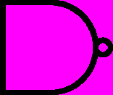When images are rendered every pixel of this exact pink colour will be set to transparent

remove_colour = (255,0,255)

this line runs whenever an image is created

self.image.set_colorkey(remove_colour)#make background transparent

## Analysis of second iteration

### The second prototype

My second iteration produced a functional prototype that demonstrated the full GUI and the logic computations.

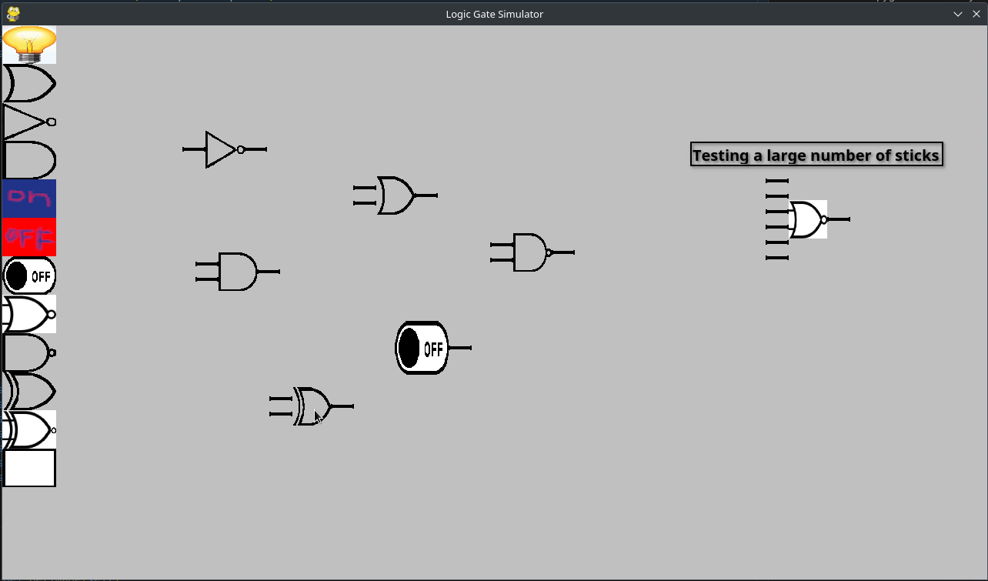It includes sticks which connect to components, sticks act as the inputs and outputs of the components, each component has the correct number of sticks as inputs and outputs (eg. NotGate has only one input). And the number of sticks is defined in the code and can be changed to any number. The program will correctly position the sticks centred but with enough spacing no matter how many sticks there are. The sticks follow the component when it is moved so it looks like they are just one object.

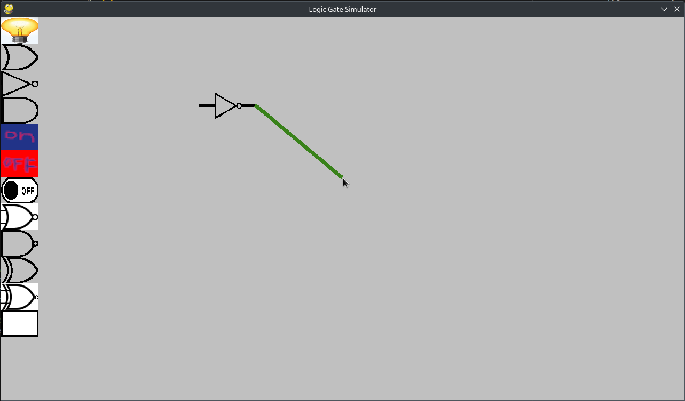

If a stick is clicked a wire will be created and connect from the stick to the mouse cursor. It will follow the mouse and rotate around its origin stick until placed or the user releases the mouse button.

When the wire is near another stick it connects to it and if the user releases the mouse button it will stay there an make an official connection.

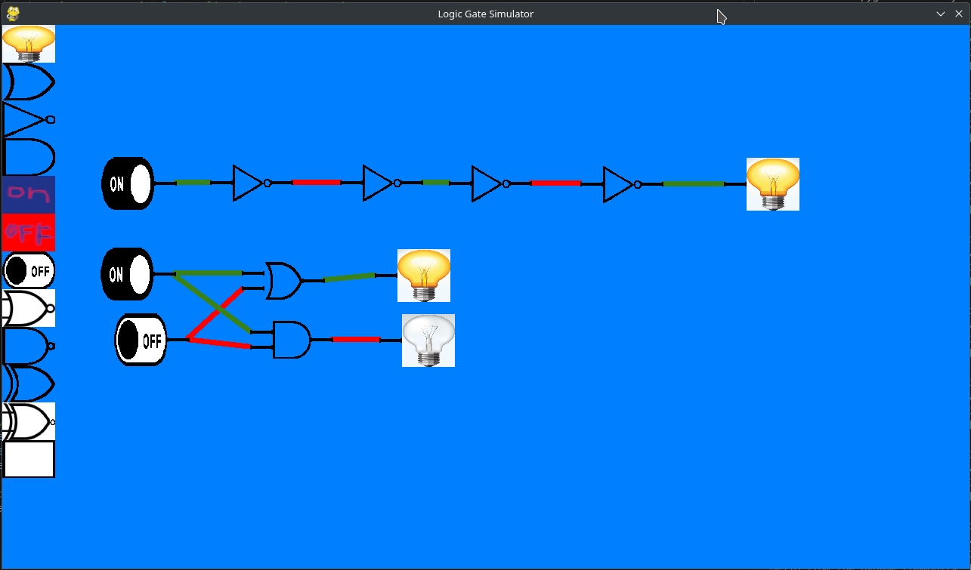

Finally the logic gates are simulated and update automatically when something changes (like a switch switching) and follow the rules of logic gates. There is visual feedback as the wires change colour and bulbs light up to indicate their state.

### User feedback of second iteration

The feedback from potential customers was mostly positive they praised the design of the wire connections controls and agreed that the program was fun to mess around with. They also liked the remade logic gate images that made the program look “just like a logic gate diagram”.

They found the logic simulation unsatisfactory as things updated instantly and in a wired order and certain circuits caused crashes.

I was concerned that the program did not provide enough visual feedback if a component is on or off. Currently wires and lamps change image if on or off but nothing else. However all the users felt that this was good and liked that it logic gates looked like a logic diagram.

They found this prototype to have a few crashes but I was aware of that already.

**Testing**

To test the code I will run the tests from my test plan.

|  |  |  |  |  |
| --- | --- | --- | --- | --- |
| Test No. | Test Description | Failed/passed | Output description (if test failed) | Evidence |
| 1 | Test that program closes when OS x button is pressed | Pass |  |  |
| 2 | Test that a new components is created when logic gate button is clicked | Pass |  |  |
| 3 | Test if components can be created with keyboard shortcuts | Fail | This functionality has not get been implemented |  |
| 4 | Component clicked on follows the mouse | Pass |  |  |
| 5 | Wires created when connection point clicked that connects the mouse position the connection point | Generally Pass. Except in rare circumstance the program crashes so this is a Fail | If the wire is at an angle of 180 degrees, error division by 0 |  |
| 6 | Move wire near connection point and wire will ‘jump’ to the connection point | Pass |  | notice that the wire connects to the connection point even though the mouse is only near the connection point |
| 7 | When the mouse is released not near a connection point the wire disappears | Pass |  | It is hard to show something not happening with an image |
| 8 | Attempt to connect an input wire to another input wire and they do not connect | Pass |  | notice the wire does not snap to nearby input |
| 9 | Test if And gate is correctly simulated and acts according to its inputs and And gate rules | Pass |  |  |
| 10 | Connect a not gate output to its input making a clock | Fail | Crash max recursion depth reached |  |
| 11 | Create race condition | Fail | The logic updates are all done in one frame so the update order cant be seen |  |

Tests 12 to 14 not relevant yet as feature not yet implemented

Due to the unexpected failure of test 10 and 11 I realised further testing is required of the logic simulation

Some bugs were identified: when rotating the wires around at a specific point the program would crash giving a division by 0 error.

angle = math.degrees(math.atan(abs(point1[0] - point2[0])/ abs(point1[1]- point2[1])))

I found the culprit. It is completely possible for the denominator to be 0 if the wire is at a specific point and that causes the error.

**Logic update issues**

If a loop of gates is made (a clock) the program crashes from “max recursion depth reached” error. This happens because depth first search tries to find the end node of the graph and there is no end node.

Secondly race conditions can occur in logic circuits. They “typically occur when a logic gate gets inputs from signals that have traversed different paths while originating from the same source. This results in a timing error or a glitch (temporary or permanent) that causes the output to change to an unwanted state before settling back to the desired state” <https://cwe.mitre.org/data/definitions/1298.html> accessed 13 april 2023. Race conditions are something circuit designers should avoid but currently in my program they are handled poorly as one branch is fully updated before the next branch. This is neither intitive nor realistic.

Finally in real logic cicuits updates are not processed instantly but instead there is a propagation delay as current passes thought the wires and gates have a small delay before switching state. So it would be better if the logic updates happened across multiple frames and the user could see the components updated in order and it would solve the issues with race conditions.

## Breakdown of third iteration

**Fixing logic updates**

As the logic updates where unsatisfactory in the previous iteration I decided to switch from a pre-order depth first search to a breadth first search (bfs) as that is more realistic to the way logic gates update and fixes the infinite loop and race condition issues. I will also limit the update speed to one level of the graph per frame (and allow the user to increase the speed if desired) to create propagation delay. This means instead of the components instantly updating the user can see the components updating 1 at a time but very quickly. This will make my program more similar to a real logic circuit and fixes the issues raised in the analysis of second iteration.

To do this the “changes” variable was changed to a list so many components can appended to it. “changes” is now the queue for the bfs. And I removed the recursive logic update calls from every “logicUpdate” method.

The updates will all be controlled from the main loop.

#apply logic updates to all components that have been changed

if changes:

for i in range(sim_speed):

changes.append(False)#split changes into sections

while True:

if changes[0] != False:

changes[0].logicUpdate()

if isinstance(changes[0], Wire):#enqueue child nodes to changes

changes.append(changes[0].outputs.its_component)

else:

for j in changes[0].outputs:

for k in j.its_wires:

changes.append(k)

del changes[0]

else:

del changes[0]

break#if nothing left to update or end of a section

The first loop is is used to run multiple cycles of the logic update per frame if desired to increase the simulation speed. In normal circumstances sim_speed will equal 1, so the loop will only run once. Later on I will add a way for the user to change value of sim speed. If sim speed is set to 0 the loop will not run and no logic updates will be processed pausing the simulation. This is a nice unexpected bonus feature.

The logic updates follow a normal breadth first search. The first item on the queue is visited (by calling ‘logicUpdate()’ on it). Then all its child nodes are appended onto the queue as well. The first item that has just been processed is then removed from the queue and this process repeats until all components have been ‘visited’ and the queue is empty. Except…….

I need not all the logic updates to be processed instantly in one frame but to space them out for visual reasons discussed earlier. If a loop was created the program would get stuck in an infinite loop and never render another frame.

My solution is to not process all of the queue immediately but to do some each frame. To do this the queue is split into chunks by appending ‘false’ to the queue at the beginning of this section acting as a split in the queue.

This separates the list into chunks and all the components in a chunk are at the same depth in the graph. The while loop calls the logic updates directly until it reaches ‘a false’ when it will stop. And wont do the rest of the queue until the next frame. This means all the logic updates in one layer are done first. And the next layer is done in the next frame (assuming sim speed is 1).

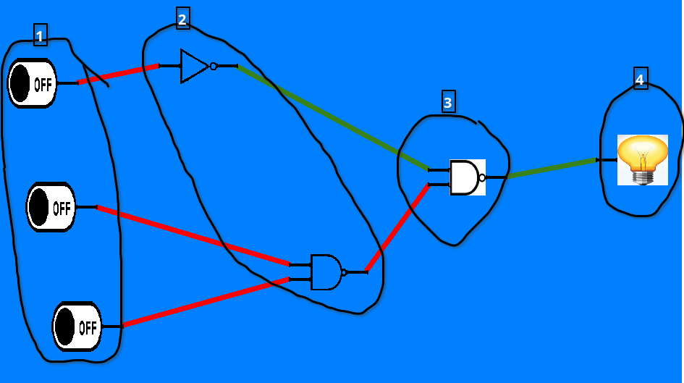**Division by 0 crash**

Next I address the division by 0 at a specific angle issue.

angle = math.degrees(math.atan(abs(point1[0] - point2[0])/ abs(point1[1]- point2[1])))

This is the problematic line if point1[1] – point2[1] = 0 there will be a division by 0 error.

#rotate around point

if point1[1] == point2[1]:#avoid division by 0

if point1[0] > point2[0]:

bearing = 90

else:

bearing = 270

#raise Exception("div by 0")

else:

angle = math.degrees(math.atan(abs(point1[0] - point2[0])/ abs(point1[1]- point2[1])))

To fix the issue I add an if statement to check for this case and set the correct bearing manually without running the problematic line.

**menus**

Next I add some menus to control the settings. I add a menu class to make the buttons, it is very similar to previous classes but it includes a parameter “where” to define its position.

class menu(pygame.sprite.Sprite):

def __init__(self, thing, where):

pygame.sprite.Sprite.__init__(self)#make image

self.image = pygame.Surface([100, 50])

self.image = font.render(thing, True, (0,0,0))

self.rect = self.image.get_rect()

self.rect.topleft = (where)#put in correct position

Next I define all the buttons as instances of this class with a position and a type parameter.

save_button = menu("save", (screen_width-200,50))

load_button = menu("load", (screen_width-200,100))

clear_button = menu("clear", (screen_width-200,150))

background_button = menu("background", (screen_width-200,200))

sim_speed_button = menu("sim_speed:", (screen_width-200,250))

sim_speed_value = menu(str(sim_speed), (screen_width-185,300))

upArrow = menu("images/uparrow.png", (screen_width-150, 280))

downArrow = menu("images/downarrow.png", (screen_width-150, 305))

Then I make all the functions of the menu buttons a method of the menu class

def isClickedClear(self):

for sprite in components:

sprite.kill()

for sprite in sticks:

sprite.kill()

for sprite in wires:

sprite.kill()

global changes

changes = []

This is one of these methods it clears the screen of all components by iterating through all the groups of things and “kill()” them. The other functions are also quite simple and carry out the action of the button.

**Saving and loading**

Next I work on the final major feature: the save /load capability. In order to do this I will be using the pickle module that I have already downloaded and imported into the code.

Unfortunately it is not possible to serialise “pygame.sprite” classes as I had originally intended. My solution is to extract all the important object data into a list that can then be serialised and the object can be reconstructed with that data.

def save(self):

return (type(self), self.size, self.no_of_inputs, self.no_of_outputs, self.state, self.rect.topleft, self.id)

I start by making a save method in the component class that returns a list of all the essential attributes of that component. It includes the type of component it is as the first element. I had to add a new attribute “ID” that is a unique number for each class and is generated when the object is constructed, the IDs simply start from 0 and each new component is previous ID + 1.

Previously wires stored a reference to the stick they connect to but sticks are not serialised so ID is used to keep track of what components the wire connects to. It was also necessary to make another “save” method for the wire class as they have different attributes.

def save(self):

return (self.state, self.inputs.its_component.id, self.outputs.its_component.id, self.outputs.its_component.inputs.index(self.outputs))

The difference is wires save function stores the ID of the components it connects to but doesn’t store its positional data as that will be recalculated when it is loaded.

Next I make the save button’s save function just like the other setting buttons.

def isClickedSave():

file = open("save", "wb")

global current_ID

pickle.dump(current_ID, file)#metadata

pickle.dump(len(components), file)#metadata

for i in itertools.chain(components, wires):#iterate over all components, wires and write save data to save

t = i.save()

pickle.dump(t, file)

file.close

A save file called “save” is opened/made with a pointer called “file”. As it will store binary data it is opened in write binary mode. The first two lines are metadata and are required to reconstruct the components, storing “currentID” allows the program to add more components and continue giving unique IDs after the circuit being loaded.

Next all components and wires are iterated through, the save function is called to extract the data which is then serialised and written the next line of the save file. Once all components and wires are written to the file it can be closed. The file will have all the components on a new line followed by all the wires

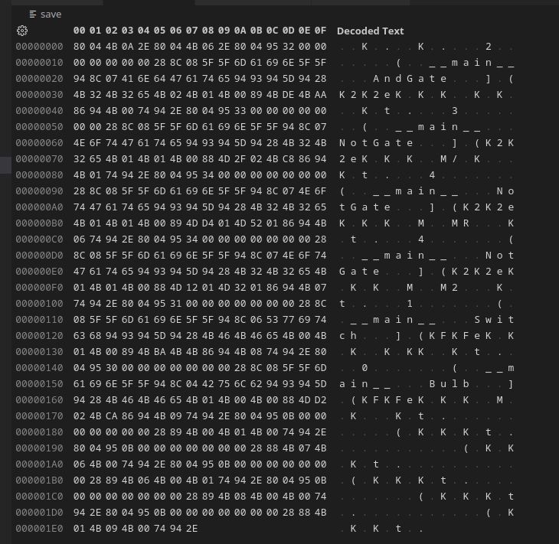

This is a save file with a few components and wires opened with a hex editor. As it is binary data it is not human readable but I will be able to reconstruct the circuits by de-serialising it with the pickle module. This creates my own file type and it could be shared over the internet so people could share their logic circuits.

Next I added functionality to the load button.

def isClickedLoad():

for sprite in components:

sprite.kill()

for sprite in sticks:

sprite.kill()

for sprite in wires:

sprite.kill()

file = open("save", "rb")

global current_ID

current_ID = pickle.load(file)#metadata

for i in range(pickle.load(file)):#load components

save = pickle.load(file)

if (str(save[0])[17:][:-2]) == "AndGate":#choose which component to make --must be a better solution than this

component = AndGate()

elif (str(save[0])[17:][:-2]) == "OrGate":

component = OrGate()

elif (str(save[0])[17:][:-2]) == "NotGate":

component = NotGate()

elif (str(save[0])[17:][:-2]) == "Off":

component = Off()

elif (str(save[0])[17:][:-2]) == "On":

component = On()

elif (str(save[0])[17:][:-2]) == "Bulb":

component = Bulb()

elif (str(save[0])[17:][:-2]) == "Switch":

component = Switch()

elif (str(save[0])[17:][:-2]) == "NorGate":

component = NorGate()

elif (str(save[0])[17:][:-2]) == "NandGate":

component = NandGate()

elif (str(save[0])[17:][:-2]) == "XorGate":

component = XorGate()

elif (str(save[0])[17:][:-2]) == "XnorGate":

component = XnorGate()

component.load(save)#add all saved data to component

components.add(component)#add to components group

while True:#load in wires

try:

save = pickle.load(file)

wire = Wire("fake", True, True)

global current_wire

current_wire = None

deb.setpos(wire.rect.topright)

wire.load(save)

except:

break

file.close

First it will clear any existing components from the screen using the same way as the clear function I explained earlier. Next the save file is opened in read binary mode. Lines are read and de-serialised from the file using “pickle.load(file)”. First I read the currentID and set the global variable currentID to that value. This ensures any new components can have a unique ID in case the user saves again.

Next the program will read in and create all the components but to do this it needs to know how many lines of the file are components and how many are wires. So the next line in the file is the number of components. Then the program iterates over each component using a for loop.

To load a component the line of the file is de-serialised and stored in local variable save. Next the program must determine what type of component it is and instantiate a new component of that type. I was not able to find an elegant solution for this so I had to use a big ‘if statement’ that compares the string that is the components name with the hardcoded name and instantiates the correct component. I am not happy with this solution as it uses many lines, is not efficient and makes adding new components harder as another line has to be added here. I may try to improve it in future.

The new component added has all the default attributes so to make it the same as the saved component I call a new method “load()” that replaces all the objects attributes with the values from “save”.

Once all the components have been created the wires are created in the same way iterating until the end of file.

def load(self, save):

global hoveringComponent

global currentID

hoveringComponent = None

self.size = save[1]

self.no_of_inputs = save[2]

self.no_of_outputs = save[3]

self.rotation = save[4]

self.state = save[5]

if save[5]:

self.turn_on()

self.rect.topleft = save[6]

self.id = save[7]

stick_seperation = 20

stick_start_y = self.rect.centery - ((stick_seperation * self.no_of_inputs) / 2)

for i in range(0, len(self.inputs)):

self.inputs[i].move_to_inp(self.rect.left, stick_start_y + (stick_seperation * i))

stick_start_y = self.rect.centery - ((stick_seperation * self.no_of_outputs) / 2)

for i in range(0, len(self.outputs)):

self.outputs[i].move_to_out(self.rect.right, stick_start_y + (stick_seperation * i))

The “load()” method takes save as a parameter and sets the components attributes to the values from “save”. It also creates the objects sticks. There is also a similar “load()” method for wires.

## Analysis of third iteration

### The third prototype:

the code I saved for this iteration doesn’t seem to work properly any more so the screenshot are not accurate to what is was like before. The up arrow used to be an arrow image.

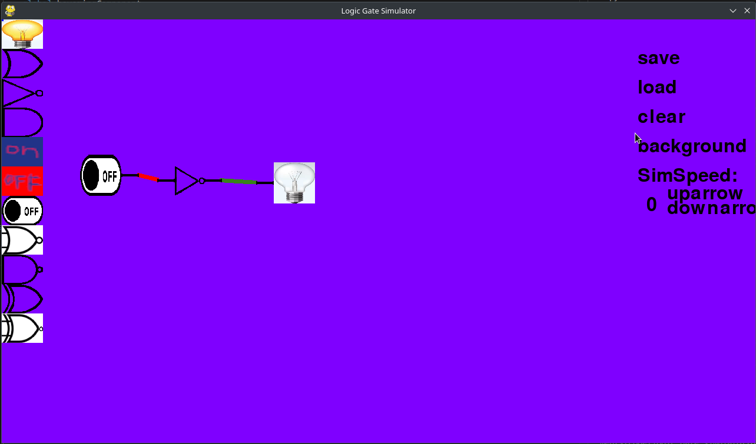My third iteration adds functional clickable settings buttons. ‘clear’ removes all components from the screen, ‘background’ changes the background colour from 9 options and the choice is saved in text file so is persistent, ‘SimSpeed’ can be adjusted up or down which changes how quickly logic updates are processed.

Finally the circuit can be saved onto a binary file and restored by clicking load even after the program is closed and reopened.

I would show an image there is not much to see in a still image

Circuits can now be saved to a binary file with the ‘save’ button and loaded with ‘load’ to recreate the original circuit exactly

Finally the logic update system has been improved massively hopefully fixing all the issues from previous iteration.

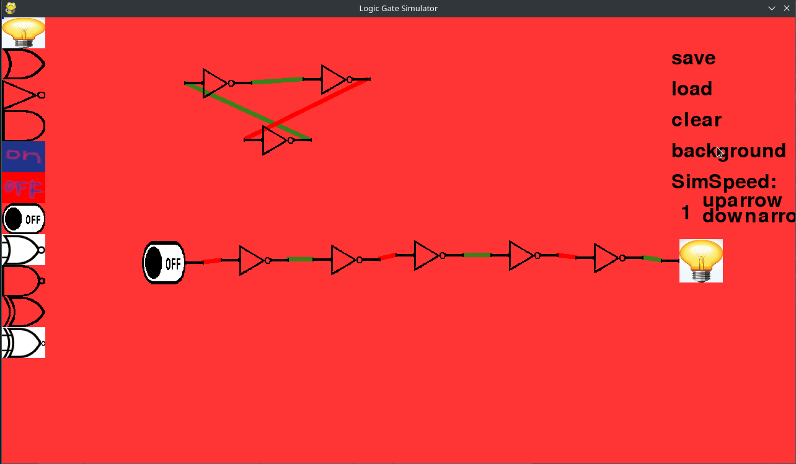In the top circuit there is a ring oscillator. It no longer crashes the program but instead cycles quickly as it has no stable state. One of the ‘not gates’ appears to be incorrect but it is working properly, it just hasn't updated yet and there will always be one not gate in this situation.

The bottom circuit demonstrates the propagation delay. Upon switching the switch the gates do not update instantly but one after the other (one per frame as sim_speed is 1) in order.

### User feedback on third iteration

logic updates much better. UI widgets bad

add decimal output, deleting components

**Testing**

Most of the tests where already passed in the previous iteration and still pass in this iterations Examiner divert your attention to tests 10 onwards

|  |  |  |  |  |
| --- | --- | --- | --- | --- |
| Test No. | Test Description | Failed/passed | Output description (if test failed) | Evidence |
| 1 | Test that program closes when OS x button is pressed | Pass |  |  |
| 2 | Test that a new components is created when logic gate button is clicked | Pass |  |  |
| 3 | Test if components can be created with keyboard shortcuts | Fail | This functionality has not get been implemented |  |
| 4 | Component clicked on follows the mouse | Pass |  |  |
| 5 | Wires created when connection point clicked that connects the mouse position the connection point | Pass, except in rare circumstance the program crashes | If the wire is at an angle of 180 degrees, error division by 0 |  |
| 6 | Move wire near connection point and wire will ‘jump’ to the connection point | Pass |  | notice that the wire connects to the connection point even though the mouse is only near the connection point |
| 7 | When the mouse is released not near a connection point the wire disappears | Pass |  | It is hard to show something not happening with an image |
| 8 | Attempt to connect an input wire to another input wire and they do not connect | Pass |  | notice the wire does not snap to nearby input |
| 9 | Test if And gate is correctly simulated and acts according to its inputs and And gate rules | Pass |  |  |
| 10 | Connect a not gate output to its input making a clock | Pass |  |  |
| 11 | Create race condition | Pass |  |  |
| 12 | Create circuit, save it, load it and see if output it identical | Pass |  |  |
| 13 | Test clear button | Pass |  | Do you really want to see a blank screen |
| 14 | Deleting components | Fail | This feature hasn't been implemented yet. |  |

## Breakdown of fourth iteration

**Better settings buttons**

To improve the settings buttons I will instead use a library called Pygame widgets. It allows adding many types of buttons and a slider. And makes it easy to have pressing feedback and to adjust the look.

First I download and import the library to my code.

import pygame_widgets

from pygame_widgets.button import Button

from pygame_widgets.slider import Slider

from pygame_widgets.textbox import TextBox

Then I add some buttons and define all the visual characteristics.

#settings buttons

save_button = Button(screen, screen_width-80, 0, 80, 30, text='save', hoverColour=(255, 0, 0), inactiveColour=(165, 0, 0), pressedColour=(0, 255, 0), radius=4, onClick=lambda:isClickedSave())

load_button = Button(screen, screen_width-80, 30, 80, 30, text='load', hoverColour=(0, 255, 0), inactiveColour=(0, 165, 0), radius=4, onClick=lambda:isClickedLoad())

clear_button = Button(screen, screen_width-80, 60, 80, 30, text='clear', hoverColour=(50, 80, 255), inactiveColour=(135, 206, 242), radius=4, onClick=lambda:isClickedClear())

background_button = Button(screen, screen_width-80, 90, 80, 30, text='background', hoverColour=(200, 100, 0), inactiveColour=(255, 165, 0), radius=4, onClick=lambda:isClickedBackground())

sim_speed_slider = Slider(screen, screen_width-80, 132, 60, 8, min=0, max=99, step=1, handleRadius=7, handleColour=(69,69,69))

output = TextBox(screen, screen_width-32, 157, 0, 0, fontSize=30, borderThickness=0, colour=(0,15,0,80))

The parameters define the location and visual appearance and the action of the buttons. I made full use of the button appearance customisation to make the buttons have vibrant colours, text to say what the button does, make them have a hover colour and rounded corners. The “onClick” parameter contains the name of the function called when clicked. I am able to reuse the click functions from the previous version iteration of the widgets.

I also add a fancy slider to control the value of “sim speed” and a “TextBox” to display this value as a number.

This is the library forcing me to break my naming conventions its not my fault ok.

To make the buttons update to user input and make the text box display the value of the slider I add these lines to the main loop.

pygame_widgets.update(events)#update widgets

output.setText(simSpeedSlider.getValue())

**Automatic load of save**

I realised it would be nice if the save file was automatically loaded upon starting the program and that is very easy to do. I just call the load function just before the main loop starts. The line is placed inside a try except as if the save file doesn’t exist or is corrupted it would be impossible to open the program without it immediately crashing. So if the something goes wrong the code just gives up on the idea and does nothing (pass).

try:

isClickedLoad()

except:

pass

# -------- Main Program Loop -----------

**One extra component**

I decided that there was need for a new component to output a numerical value: the decimal output. This component takes its inputs as a binary number and displays the decimal equivalent as output.

class DecimalOutput(Component):

def __init__(self):

self.size = [50,62]

self.no_of_inputs = 5

self.no_of_outputs = 0

self.state = None#need solution for saving its funny state

super().__init__()

def getImage(self):

return pygame.image.load("images/decimalOutput.png").convert()

def load(self, save):#workaround to ensure text is created when loaded as text value not stored

super().load(save)

changes.append(self)

def logicUpdate(self):

num = ""

for i in range(self.no_of_inputs):

try:

if self.inputs[i].its_wires[0].state == True:

num = num + "1"

else:

num = num + "0"

except:

num = num + "0"

num = int(num,2)#convert binary to decimal

component_image = pygame.image.load("images/decimalOutput.png").convert()

component_image = pygame.transform.scale(component_image, (self.width, self.length))

self.image.blit(component_image, (0, 0))

self.image.blit(font.render(str(num), True, (0,0,0)), (10, 10))

As this is just another component it is very similar to the other components. It inherits from ‘component’ however unlike most other components it has 5 inputs and no outputs and it doesn’t have a boolean ‘state’ like other components but instead a number that it displays.

The ‘logicUpdate()’ method is quite unique, it goes though all the inputs and append them to a sting called ‘num’ as 1’s or 0’s treating an unconnected input as 0. The ‘num’ is then converted to an integer using ‘int’ function with the second parameter confirming that the input is binary. The decimal value is then blitted onto the image so it can be seen.

There was one problem: as ‘num’ is not saved the upon reloading the circuit the value would not show. My solution is simply to calculate it upon loading the component. I do this by making a new load class for ‘DecimalOutput’ that overrides the one from the parent class. All it does is call the normal load method using super and then add itself to changes to be ‘logicUpdate()’d this will calculate the value for decimal output and display it.

**Removing components**

Before I can delete components I have to detect if they are clicked on. Pygame provides the ‘collidepoint()’ function to do this but it is bad when rotating rects. Instead of making a rotated hit-box Pygame forces a square hit-box and just makes it bigger so the whole object fits. This is no good for my program as a rotated wire could easily end up having a hit-box half the screen size. To fix this I decided not to call ‘self.rect = self.image.get_rect()’ to create a new useless hitbox but instead to keep the original hit-box that is unrotated.

To compensate for the rotation I made a new collision detection function that takes the mouse coordinate and using trigonometry compensates for the unrotated hit-box by changing the ‘mouse_pos’ by rotating it in the opposite direction to the rotation of the component. Then the regular collision detection is called on the corrected mouse position using the old hit-box and the output is returned. Unbelievably this actually works.

def customMouseCollisions(self, mousePos):

if self.rotation == 0:#skip if rotation is 0 for optimisation

return (self.rect.collidepoint(mouse_pos))

#pythag theorum

distance = math.sqrt(((self.correct_pos[0] - mouse_pos[0]) ** 2) + ((self.correct_pos[1] - mouse_pos[1]) ** 2))

if distance <= self.length + 10:#plus a little extra

if distance != 0:#avoid divide by 0

angle = math.degrees(math.asin((abs(mousePos[0] - self.correct_pos[0]))/ distance))

#bearings from south clockwise positive

if (mouse_pos[0] - self.correct_pos[0]) > 0:#mouse right of obj

if (mouse_pos[1] - self.correct_pos[1]) < 0:#mouse above obj

bearing = 180 - angle

else:#mouse bellow obj

bearing = angle

else:#mouse left of obj

if (mouse_pos[1] - self.correct_pos[1]) < 0:#mouse above obj

bearing = 180 + angle

else:#mouse bellow obj

bearing = 360 - angle

else:

bearing = 0

else:

return False

new_bearing = bearing - self.rotation

distance = distance * (75 / self.length)

new_coord = (self.rect.left + (math.sin(math.radians(new_bearing)) * distance), (self.rect.top + (math.cos(math.radians(new_bearing)) * distance)))

return self.rect.collidepoint(new_coord)

Now I can write the code to remove the components. This is put directly in the main loop.

#remove components

if event.type == pygame.KEYDOWN and event.key == pygame.K_BACKSPACE:

for comp in itertools.chain(wires, components):

if comp.customMouseCollisions(mouse_pos):#check if mouse is over a component

if isinstance(comp, Wire):#if it is a wire

changes.append(comp.outputs.its_component)#once wire is removed logic update is required

comp.outputs.its_wires.remove(comp)#remove references to the wire

comp.inputs.its_wires.remove(comp)#remove the wire

comp.kill()#inconsistant if this line not present

break

else:#if it is a component

if comp == hovering_component:

hovering_component = None#fixes a little bug

for stic in itertools.chain(comp.inputs, comp.outputs):# all traces of the component will be

for wire in stic.its_wires:# hunted down and defeated including

changes.append(wire.outputs.its_component)# wires that connect to it and references

wire.inputs.its_wires.remove(wire)# to those wires

wire.outputs.its_wires.remove(wire)

wires.remove(wire)

sticks.remove(stic)

stic.kill

components.remove(comp)

comp.kill

break#avoid unnecessary looping

If the backspace button is pressed the code iterates thought all components and wires checking for collisions with the mouse cursor making use of ‘customMouseCollisions()’ to do this. If a collision is found the program checks if it is a wire or a component using ‘isinstance’ as it needs to behave differently in each case. Removing objects in python is wired as it uses a garbage collector and to delete an object you just remove all references to it. If it is a wire the references to that wire in other component classes are removed. And I also remove the wire from the ‘wires’ group. This is usually enough to remove the wire but not always so I added ‘comp.kill()’ to finish it off.

If the user is trying to remove a component all the wires connected to it also are removed as it would be strange to leave some wires not connected to anything. So I have to delete the component, its sticks, its multiple wires and the references to those wires.

When components are removed there output components may need to update their state as their input has changed (disappeared). To fix this I append the outputs to ‘changes’ so they get a logic update.

## Analysis of fourth iteration

### Fourth prototype

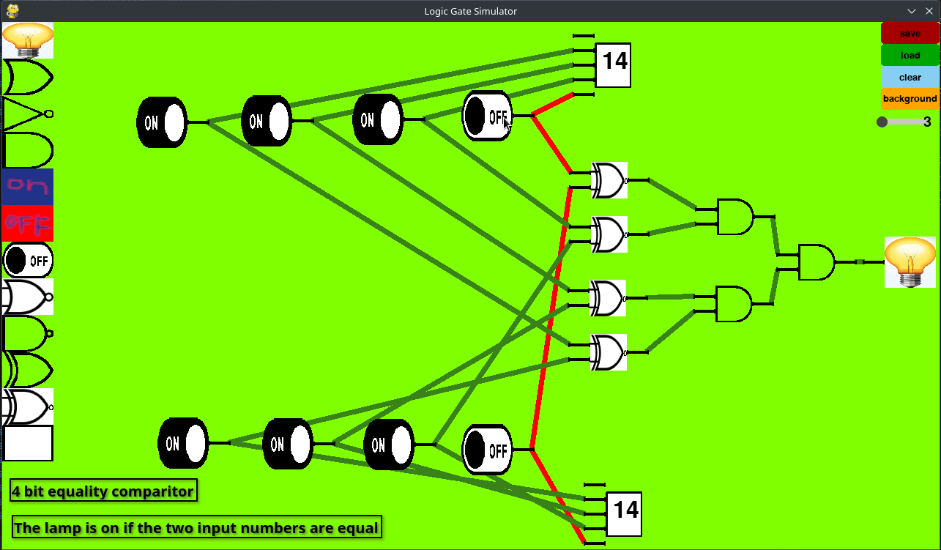My fourth prototype massively improves the settings buttons at the right. Using ‘Pygame Widgets’ library the buttons look better with clicking animations and a hover colour. The ‘sim_speed’ is adjusted with a slider.

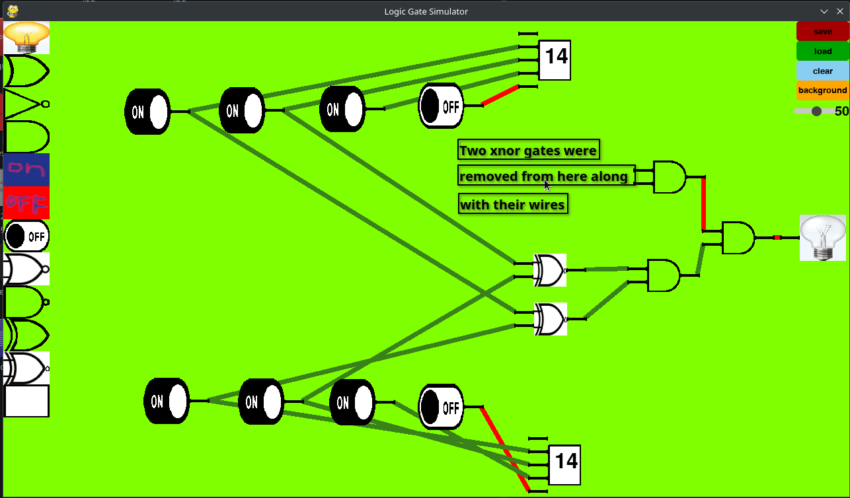It added an extra component, the decimal output, that takes a binary input and displays the decimal equivalent improving the feedback that the logic circuits can provide.

Finally components and wires can be removed by hovering over them and pressing ‘backspace’. This is a rather essential editing feature my program was previously missing.

### Feedback on fourth iteration

The users approved of the new settings buttons and found that all essential features of a logic gate simulator where present and working well.

Although there are still some additional features that could improve the program. As this prototype is feature complete and the users found the program satisfactory this prototype will be used as the final version.

# Evaluation

## Testing for robustness

|  |  |  |  |  |
| --- | --- | --- | --- | --- |
| Test No. | Test Description | Failed/passed | Output description (if test failed) | Evidence |
| 1 | Test that program closes when OS x button is pressed | Pass |  |  |
| 2 | Test that a new components is created when logic gate button is clicked | Pass |  |  |
| 3 | Test if components can be created with keyboard shortcuts | Fail | This functionality has not yet been implemented |  |
| 4 | Component clicked on follows the mouse | Pass |  |  |
| 5 | Wires created when connection point clicked that connects the mouse position the connection point | Pass, except in rare circumstance the program crashes | If the wire is at an angle of 180 degrees, error division by 0 |  |
| 6 | Move wire near connection point and wire will ‘jump’ to the connection point | Pass |  | notice that the wire connects to the connection point even though the mouse is only near the connection point |
| 7 | When the mouse is released not near a connection point the wire disappears | Pass |  | It is hard to show something not happening with an image |
| 8 | Attempt to connect an input wire to another input wire and they do not connect | Pass |  | notice the wire does not snap to nearby input |
| 9 | Test if And gate is correctly simulated and acts according to its inputs and And gate rules | Pass |  |  |
| 10 | Connect a not gate output to its input making a clock | Pass |  |  |
| 11 | Test race condition are handled properly | Pass |  |  |
| 12 | Create circuit, save it, load it and see if output it identical | Pass |  |  |
| 13 | Test clear button | Pass |  | Do you really want to see a blank screen |
| 14 | Deleting components | Pass |  |  |

**Stress testing**

As my program allow the user to make an unlimited number of components that could be doing a lot of logic updating. Significant stress could be put on the program so I test if the system can handle it efficiently. Very large circuits could be created if someone was crazy enough to try and make a logic computer in my program.

First I test creating and rendering an unreasonable number of objects by temporarily modifying the code to create a new component every frame, to print out the fps, print the number of components and uncap the frame rate.

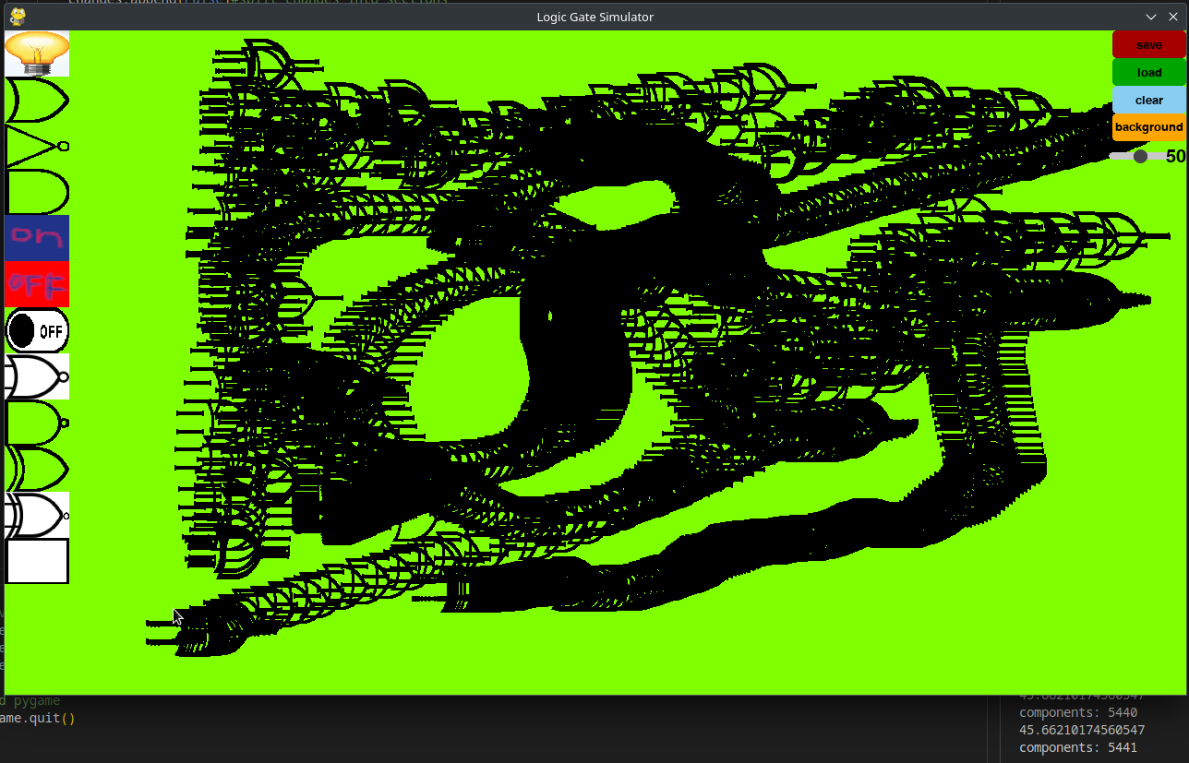As can be seen in the screenshot at 5441 ‘or gates’ the fps had dropped to 45 so the program is still perfectly useable with 5441 ‘or gates’ on my computer. This is a great success and a less powerful computer should still be able to handle a sufficient number of logic gates.

I also decided to stress test the logic update system. The easiest way is to set the ‘sim_speed’ to the unreasonable value of 3000. This way more than the program will let the user set and build this constantly updating clock. This is roughly equivalent to building the circuit 3000 times with ‘sim_speed’ of 1 (in terms of logic updating).

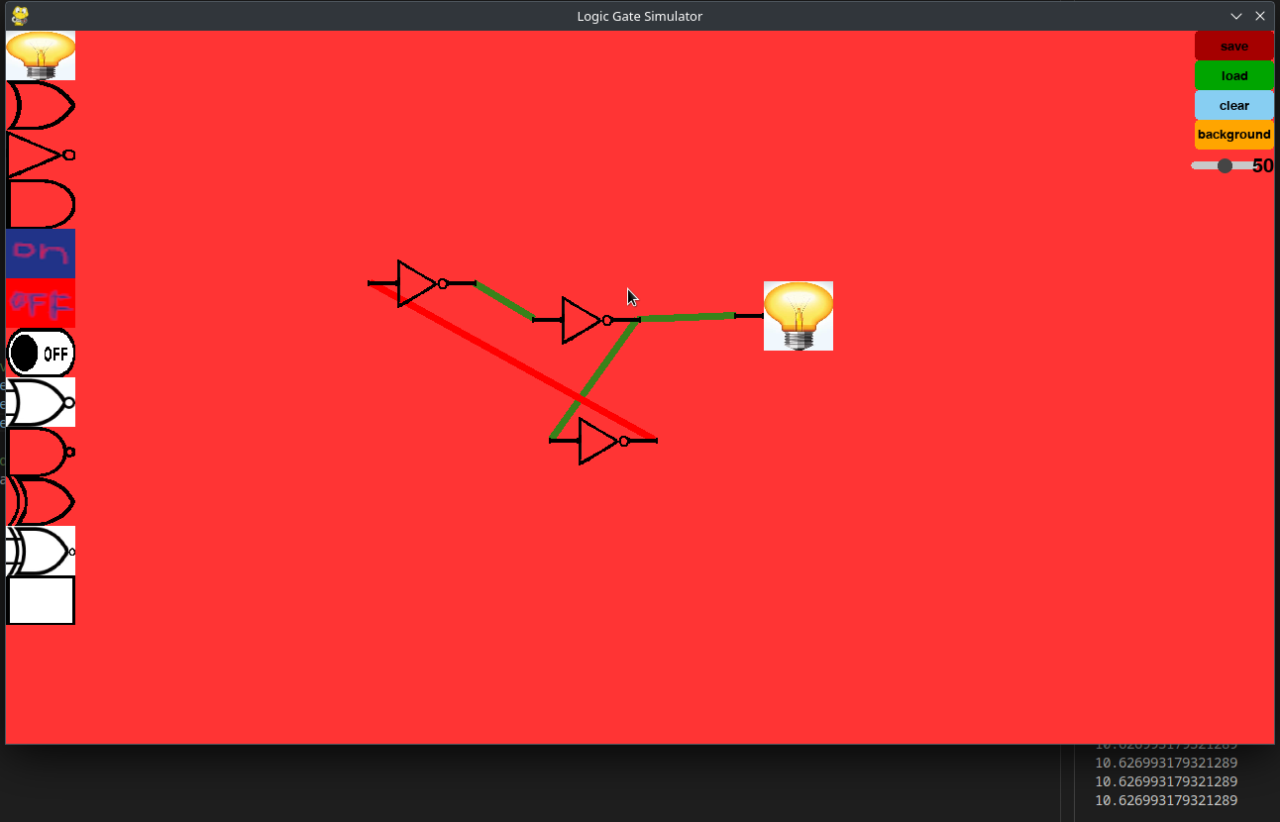

Ignore the ‘sim_speed’ slider, at a sim speed of 3000 this circuit brought the frame rate down to 11 fps. This is also a success however it could be improved, for instance using multi-threading as the program is currently completely single threaded.

## Usability testing

To test the usability of the program I asked 5 people to use the program as I watched and complete a questionnaire afterwards to give feedback. After they had experimented with the program for a while I asked them to construct a simple logic circuit with 3 gates from an image I showed them and then to save and load it.

|  |  |  |
| --- | --- | --- |
| **Question:** | **Yes** | **No** |
| Do you think the GUI is visually appealing and easy to understand? | 4 | 1 |
| Is it clear how to make new components? | 5 | 0 |
| Is it clear how to connect with wires? | 3 | 2 |
| Are the buttons the right size and clearly buttons? | 5 | 0 |
| Is the state of the components clear? | 4 | 1 |
| Do you now understand how to build any circuit | 5 | 0 |

All users where able to complete the tasks and gave generally positive feedback on the usability. From my observations and the questionnaire I noticed that the drag and drop GUI is very intuitive to computer users as it is commonly used in programs. The wires however are not so obvious as there is nothing to indicate that the ‘connection points’ should be clicked, however once the users work this out the system is easy to use. This could possibly be mitigated by creating a short text appears on the screen explaining it when the program is first run.

I was not able to test on people who are not familiar with computers however as the program is teaching a complex computational idea these people with limited computing understanding are not the target audience.

One user mentioned usability for colour-blindness. Most aspects of my program can be distinguished by colour blind people as logic gates are distinguished by shape and the ability to change the background colour allows colourblind people to choose a colour they can see most clearly such as white. The main thing that many colour blind people can’t distinguish is the red and green wire and red-green colour-blindness is the most common. To fix this the green wire image could be changed to have a electricity lightning symbol on them or similar and this would require no change to the code just to an image.

## Success of the solution

|  |  |  |
| --- | --- | --- |
| Feature | Success | Evidence |
| Create GUI and respond to user input | Yes | Look at any screenshots |
| Visually appealing GUI | This was mostly successful as it makes use of Pygame widgets to make nice functioning buttons, it has nice looking logic gates and satisfying wire movement. | 4 out of 5 usability testing users said it was visually appealing and easy to understand. |
| Ability to create logic gates with one click | Yes | Test 2, 4 |
| Ability to connect logic gates with wires. And it is intuitive for users. | Partially successful this feature functions correctly but not all users found this system completely intuitive. However this is always going to be difficult due the limitations of the input device and I think I did it in the best way possible. | Test 5, 6, 7  Only 3 out of 5 usability testing users said it was clear how to connect components with wires. |
| Protect user from connecting wires incorrectly | Yes, the wires will not connect in invalid ways | Test 8 |
| Create logic gates with keyboard shortcuts | No, I didn’t have time to add this feature. However it is not essential for the program to be useful. |  |
| Ability to delete components | Yes, components are deleted by pressing the backspace key | Test 14 |
| Accurate logic simulation | Yes | Test 9, 10, 11  I also demonstrated a working 4 bit binary adder, a D flipflop and an RS flipflop. See below. |
| Accurate saving and loading | Yes | Test 12 |

I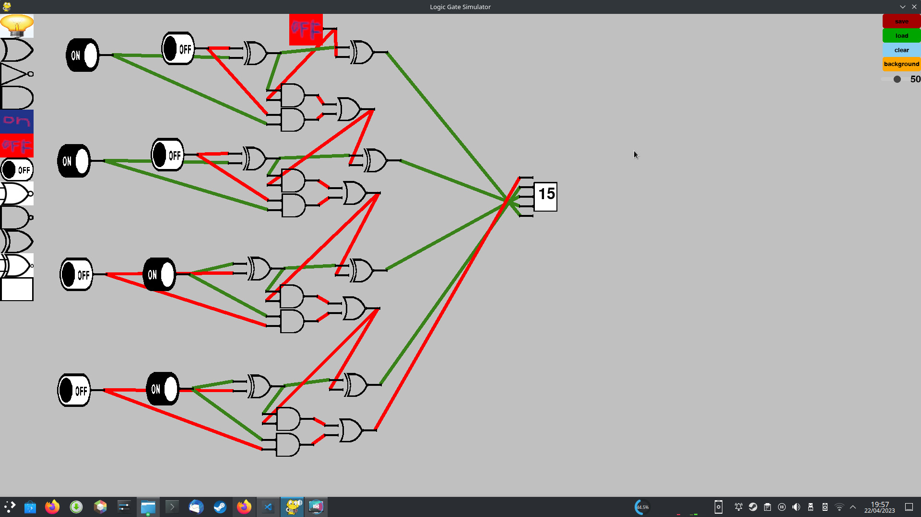 constructed the circuits I described in the success criteria and they functioned correctly.

Binary adder functioning correctly

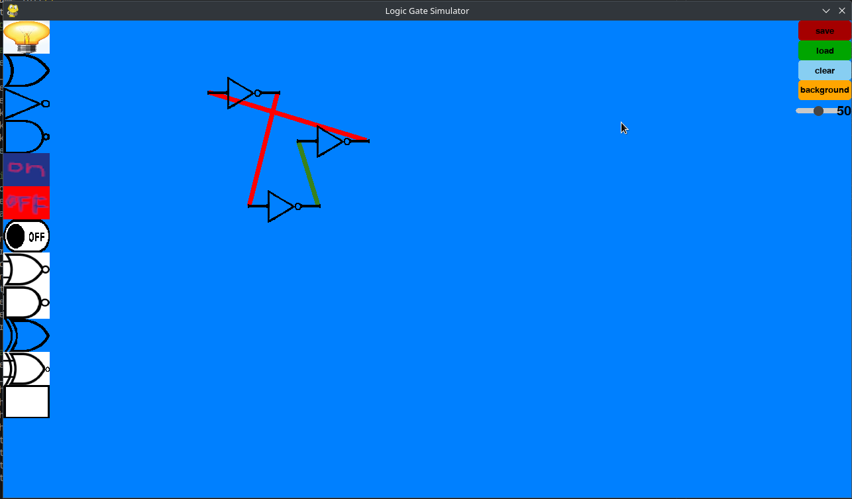Ring oscillator. Although it can’t be seen from a screenshot it cycles on and off very quickly. The top not gate is not broken it just hasn’t updated yet and there will always be one not gate like this as it has no stable state.

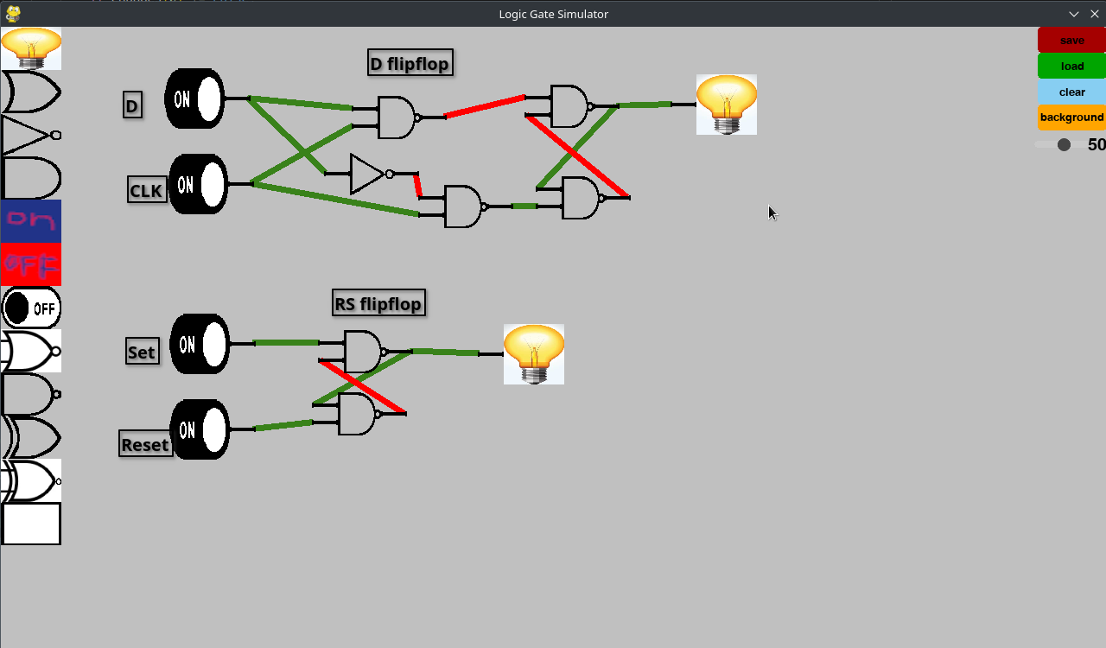SR and D flip flops.

As my program is capable of correctly simulating complex logic circuits like a binary adder and various flip flops it is definitely capable of simulating simple circuits that is the intended use case. It could be used to construct a virtual computer but it is not ideal for that.

In some ways my program improved upon my original design, for instance it enables the user to slow down, speed up or pause the simulation to allow to easier debugging of circuits. And it allows the user to increase the number of inputs of a logic gate to have 3 way and gates for instance.

## Maintenance and development

My solution is very maintainable as there is nothing that needs to be done to keep it running. The inputs devices are the keyboard and mouse which have been used for a very long time and will continue to be used for the foreseeable future.

As the code doesn’t rely directly on the OS but instead uses Pygame the program will remain compatible as long as Pygame 2.1.2 remains compatible. The program is likely to be able to update to future versions of Pygame with minimal or no changes if it is necessary. However, it is unlikely to need changes as the program only relies on basic OS features that are unlikely to change. As the program is entirely offline there is no need to maintain servers or websites which massively reduces the need for maintenance.

My program is unlikely to contain any significant bugs as it has passed the tests in the test plan and has been used by many users and no issues were found. If there are any bugs remaining it its likely to not significantly affect the usefulness of the program. If any are found they could also be patched in future updates.

## Potential further development

Although my program is complete there is still a lot of features that could be improved and additional features that could make it better that could be added in future updates.

Additional logic gates or input methods could be added. This would be very easy due to how the system was designed. I would just add a new class for that logic gate that inherits from component and has its own unique image and ‘logicUpdate()’ method, just like the other logic gate classes

A useful feature of many logic gate simulators but not mine is ‘Circuit blocks’. Any logic circuit that the user makes can be saved as a circuit block that is one custom component that does the same as the circuit that was saved and can be re-used regularly like functions in programming languages.

To improve performance in very large circuits multi-threading could be used currently both rendering and logic updates are on the same thread and separating them could allow these two things to be done concurrently doubling performance.

Currently wires connect components in a straight line. But it would be nice if the user could wire wires neatly to make the circuit easier to understand.